INCLUDEPICTURE "http://www.ucu.org.uk/images/common/toplogo.gif" \* MERGEFORMATINET INCLUDEPICTURE "http://www.ucu.org.uk/images/common/toplogo.gif" \* MERGEFORMATINET 

Meeting of: Representatives from Retired Members’ Branches
Location: UCU head office
Date: 19 November 2014

Confirmed minutes

Present: Tina Downes (in the chair), Yorkshire & Humberside RMB
Julian Atkinson, East Midlands RMB
Rob Kirkwood, East Midlands RMB
Geoff Goddin, London RMB
David Binns, London RMB
Tom Bimpson, North West RMB
John Williams, North West RMB
Norman Jemison, Northern RMB
Emily Fawcus, Northern RMB
Alastair Hunter, Scottish RMB
Terry Brotherstone, Scottish RMB
Ken Childerhouse, South East RMB
Jo Corke, South West RMB
Ruth Amias, South West RMB
Andrew Currie, Southern RMB
Gail McFarlane, Southern RMB
Kate Clayton, West Midlands RMB
Dave Sheridan, West Midlands RMB
Paul Russell, Yorkshire & Humberside RMB
Lloyd Wilson, Eastern & Home Counties RMB
Roy Batt, Eastern & Home Counties RMB

In attendance Liz Lawrence (President, item 3), Paul Cottrell (National Head of Democratic Services), Sue Bajwa (conference officer), Kay Metcalfe (minute-taker)

- Opening business, election of Chair
  - Paul Cottrell introduced himself and other members of staff present and welcomed representatives to the meeting.
1.2 The meeting elected Tina Downes Chair of the meeting.
1.3 It was agreed that UCU nominations to the National Pensioners’ Convention (NPC) would be taken under item 7, other reports. Liz Lawrence, President, would address the meeting at 12pm.
2 Motions submitted by branches
2.1 Motion 1 Pensioners against Racism was moved by David Binns of the London Retired Members’ Branch.
A minor amendment was AGREED to insert ‘policies of’ before ‘UKIP’ in the last paragraph.
Motion 1, as amended, was PASSED:
This UCU Retired Members Annual Meeting congratulates the union on its recent pamphlet "Why Immigration Is Good for All of Us".
We note that UKIP is specifically targeting pensioners, at the same time as recognising that the cuts they propose would have a disproportionately high, detrimental effect on older people. Further we recognise the importance of immigrant workers in the NHS and care for the elderly.
We therefore resolve to actively campaign amongst pensioners and UCU branches against both policies of UKIP and against the accommodation of the principal parliamentary parties to the rise of UKIP which has encouraged its anti-immigrant message.
2.2 Motion 2 Defend Universal benefits was moved by Geoff Goddin of the London Retired Members’ Branch. An amendment to the motion was proposed by Julian Atkinson of East Midlands Retired Members’ Branch: delete ‘refuse to……who will not’ and replace with ‘press them to’ which was AGREED.
Motion 2, as amended, was PASSED:
This UCU Retired Members Annual Meeting
Supports the NPC "CAMPAIGN TO DEFEND UNIVERSAL PENSIONER BENEFITS SUCH AS THE BUS PASS AND WINTER FUEL ALLOWANCE". We urge all our members to question all candidates in their constituency and to press them to publicly endorse the "Pensioners Manifesto 2015".
2.3 Motion 3 Developing a policy for future life was moved by Julian Atkinson of the East Midlands Retired Members’ Branch. An amendment to the motion was discussed on the right to continue working without statutory limitation but subsequently withdrawn.
Motion 3 was PASSED:
UCU has an established position of making policy and campaigning for those policy aims in areas well beyond the immediate needs of the workplace. UCU should also take positions that protect not just the present needs of the members but their needs for the future as they age.
Such policy should include:
Good occupational pensions with a realistic normal pension age and provision for premature retirement that is not actuarially reduced to an inadequacy.
Campaigning for a sufficient State Pension for all.
Opposing worsening of the benefit system particularly including those benefits associated with ill-health.
Proper funding of the NHS and social care and the reversal of privatisation.
2.4 Motion 4 was moved by Ken Childerhouse of the South East Retired Members’ Branch. In debate of the motion, some issues raised by Kate Clayton were highlighted for further discussion. These included classification of care homes as charities, staff training, wages and employment rights for those employed in care homes including volunteers and safeguards for the treatment of the elderly.
Motion 4 was PASSED:
Aware of the needs of UCU retired members, this annual meeting of Retired Members' Branches calls upon the N.E.C. to campaign for a fully comprehensive system of Adult Social Care financed out of general taxation, such provision to also guarantee that all employees involved in delivering are paid at least the Living Wage.
3 Address by Liz Lawrence, President
Liz Lawrence, President, addressed the meeting. She acknowledged the contribution of those present to education and the wider labour movement as well as the campaigning activity organised by retired members. In response, representatives highlighted the support given by retired members to those in employment through childcare, their contribution to the economy and the importance of the union’s support for the NPC.
Liz was thanked for her valuable contribution to the meeting and it was requested that her address, attached, be put on the website.
4 Motions (continued)
4.1 Motion 5 was moved by Tom Bimpson of the North West Retired Members’ Branch.
An amendment to the motion was proposed by Norman Jemison of the Northern Retired Members’ Branch: add final paragraph: ‘This conference further supports the proposal from Shadow Health Minister Andy Burnham for a national care service combined with the NHS free at the point of use and funded by general taxation.’
Following debate of the amendment, a proposal to replace ‘proposal from Shadow Health Minister Andy Burnham’ with ‘NPC policy’ was AGREED.
The amendment was PASSED. Motion 5, as amended, was PASSED:
This conference believes that a National Health Service is essential for UCU retired members and furthermore that this should be an accountable public service.
This Conference recognises the threats that this faces including:
The introduction of market principles into its operations
The increasing outsourcing of NHS services to the private sector
The reduction in the Secretary of State’s responsibility
This conference, therefore, supports the NHS Reinstatement Bill drafted by Peter Roderick and Allyson Pollock, resolves to campaign for its implementation and to work with the Keep Our NHS Public campaign to this end.
This conference further supports the NPC policy for a national care service combined with the NHS free at the point of use and funded by general taxation.
4.2 Motion 6 Pensions Policy was moved by Paul Russell of the Yorkshire & Humberside Retired Members’ Branch.
Motion 6 was PASSED:
This UCU Annual Autumn meeting of RMB delegates notes resolution 31 passed at UCU Congress 2014:
Congress notes that:

1. many of today’s pensioners, including some former lecturers, are living in officially defined poverty.
2. the new state pension will bring no change to their or any other existing pensioner’s income other than a cumulative loss of value from the use of CPI as the inflation measure.
3. the vast majority of future pensioners will receive little or no benefit from the new state pension system, which is designed to reduce the state pensions bill.
4. occupational pensions of UCU members and other workers are under sustained attack. Many members will be worse off in retirement than they had planned, and may face years of extreme hardship if they are unable to work to the ever-rising pension age.
5. Congress therefore commits UCU to campaign with other Trade Unions for a thorough review of pensions policy by a future government, not limited by an artificial austerity agenda.

In pursuing this policy we should call on any new government to undertake a serious, long term policy review, taking account of:
- the increasing attacks on occupational pensions
- the increase in part time working, often for more than one employer
- the use of fixed term contracts including zero hours contracts agency working and bogus self employment schemes
- the total inadequacy of both the existing and newly planned state pension the serious possibility of many people losing their employment long before the ever increasing retirement age.
The review should take as its starting point the real and predicted needs of all people and their right to a comfortable retirement free from financial anxiety, rather than the government’s view of what can be afforded.
4.3 Motion 7 was moved by Norman Jemison of the Northern Retired Members’ Branch.
Motion 7 was PASSED:
This Conference calls on the NEC to ensure that UCU publicises, circulates to Branches and actively supports the NPC's Pensioners Manifesto as part of its campaigning for the 2015 General Election.
4.4 Motion 8 was moved by Norman Jemison of the Northern Retired Members’ Branch.
Motion 8 was PASSED:
This Conference calls on the NEC to ensure urgent action on the restoration to membership of those Retired Members who had their membership terminated, despite having paid a one off fee for lifetime membership.
This would fulfil the terms of the motion passed at this year’s Annual Congress.
In response to a question about some lifetime members having received a request for payment, Paul Cottrell apologised for the delay in implementation of the Congress motion but letters were now being issued to members confirming reinstatement of membership. Where necessary, refunds would be made to members.
Despite numerous requests for information on reinstatement of members, Jo Corke of the South West Retired Members’ Branch expressed disappointment at the lack of a response to her letters from national officers.
4.5 Motion 9 was moved by Gail McFarlane of the Southern Retired Members’ Branch.
Motion 9 was PASSED:
This conference deplores the proposed changes to the USS scheme, noting particularly that the introduction of individual defined contribution pots not adding to the general fund will further erode its capacity to meet obligations to existing pensioners and make default more likely, with any government compensation likely to be insignificant.
While fully acknowledging the damaging impact of the proposals on the majority in employment, the Southern Retired Members Branch calls on UCU also to give appropriate weight in the negotiations to the alarming prospect of loss of income now facing retired members if these proposals go ahead.
4.6 Motion 10 was moved by Kate Clayton of the West Midlands Retired Members’ Branch.
Some possible amendments to the motion were discussed to clarify its intention. The mover of the motion proposed withdrawal of the motion which was AGREED in order that it could be considered further by a small working group comprising Kate Clayton, Paul Russell and John Williams and proposals brought to Congress 2015.
Motion 10 was withdrawn:
Conference recognises that inequality is a lifelong scourge affecting people from the cradle to the grave.
Conference also recognises that inequality appears in a multiplicity of forms - class, gender, skin colour, ethnicity, language, religion, age, disability and sexual orientation.
Conference affirms that fighting against inequality calls for the inclusion in that fight of ALL members of UCU for to exclude some members for whatever reason weakens the forces that can be engaged to fight inequality.
Conference therefore calls upon the NEC of UCU to bring to the 2015 UCU congress a rule change that will allow Retired Members to have representation on the standing committee (Equalities) so that such members are recognised as an essential and integral part of the fight against inequality in all its forms.
4.7 Motion 11 Model Motion for Trade Union RMAs was moved by Norman Jemison of the Northern Retired Members’ Branch.
Motion 11 was PASSED:
Millions of workers in the UK face a future pensions crisis when they retire. The state pension is currently ranked as 36th out of 37 OECD countries, one in six older people already live below the official poverty line of £175 a week and six million pensioners - the vast majority of which are older women - have an income less than £10,500 a year.

For years, successive governments have relied on large sections of the workforce having a decent occupational pension, based on final salary as an alternative to providing a higher state pension. However, over the last decade we have seen the gradual decline of good occupational pensions, only to be replaced by more insecure market-based alternatives where the risk lies almost solely with the individual.

As a result of insecure employment patterns, low pay and poorer pension alternatives, the vast majority of future pensioners will therefore become increasingly reliant on the state pension to form the largest source of their income in retirement.

It is therefore vital that [the name of trade union] now recognises the need to campaign more vigorously for a decent state pension system for all generations - including future members.

Following the general election this campaign should include:
- Strengthening links with Britain's biggest campaigning pensioner organisation, the National Pensioners Convention
- Lobbying the government to ensure all existing and future pensioners receive a state pension set above the official poverty level
- Calling for annual increases in pensions to be linked to the best of wages, CPI, RPI or 2.5%
- Rejecting any further attempts to raise the state pension age beyond 67.

4.8 It was AGREED that all motions passed would be forwarded to the NEC. It was AGREED to recommend that motion 5 would be submitted to the NPC biennial conference. As the NEC did not meet until 5 December, and the NPC required the motion by the end of November, this would be referred to the President for chair’s action.
5 The chair noted the sad news that Andrew Price, Secretary of Wales Retired Members’ branch, had died. A moment of silence was held.
6 Reports from branches
6.1 Members reported on the activities of their RMB. A query was raised about retired membership figures and numbers for those joining retired members’ branches. Information on joiners and leavers for RMBs was available and Paul Cottrell agreed to advise RMB branch secretaries how to access this (see attached noted from Andrew Currie).
6.2 The meeting agreed to send its best wishes to Grace Everson and Dave Harker who were unwell.
7 Other reports
7.1 Norman Jemison presented the report from Philip Burgess on his activities on behalf of UCU on the NPC and Public Service Pensioners’ Council which was NOTED.
7.2 Four delegates from UCU could attend the NPC biennial conference in March. The meeting AGREED these would be the union’s current representatives on the NPC Executive and Council, in accordance with existing practice. It was also AGREED to nominate Norman Jemison Vice-President of the NPC. Given the NPC’s deadline of end of November for receipt of nominations, this would be referred to the President for ‘chair’s action’.
7.3 The union would need to nominate one representative to the Executive of the NPC and three further representatives to its Council as the existing representatives’ terms of office ended after the biennial conference in March. Paul Cottrell reminded the meeting that following a rule change at Congress 2014, these representatives were now elected by the meeting of all RMB delegates to Congress in May (the relevant extract from the rules had been circulated with the agenda) which raised some timing issues. Paul Cottrell advised that an option would be for the current representatives to remain in office until the meeting of RMB delegates to Congress.
7.4 The meeting AGREED to recommend to the NEC the nomination of Philip Burgess, Norman Jemison, Pat Roche and Paul Russell to these positions and that they be elected by the NEC at its next meeting to enable them to take up office after the biennial conference.
7.5 Norman Jemison reported on the activities of the TUC Pensioners Committee which was NOTED.
8 AOB
8.1 Tina Downes was thanked for chairing the meeting.

Retired Members’ Annual General Meeting 19th November 2014
Address by Liz Lawrence, UCU President
Dear Colleagues, as your President I would first like to say ‘thank you’ for the decades of service to education and to the labour movement, which you have given. As education workers you will have done much to improve people’s lives and create a better society. It’s important to remember that, when we hear cheap attacks on the teaching profession and working life in universities and colleges misguidedly represented as feather-bedded.
Will future generations have retirement and pensions?
When state pensions were first introduced the pension age was set at 70 and most workers died before collecting their pensions. There are still parts of the world where most workers die before retirement. My parents were part of a generation where people had a decade or two of life between finishing work and the infirmities of old age, when they had decent occupational pensions and could enjoy life. I hope you are enjoying your retirement. This was a historic gain of the labour movement, inserting a third stage of the life cycle, following childhood and education and work, and before illness or death. This achievement is now under attack. Governments and employers are raising pension ages, both for state and occupational pensions, so that the interval between retirement and death will be shorter and shorter, for those who enjoy any retirement at all.
What we have seen too is a distortion of the equality agenda. It is one thing to argue on grounds of ending age discrimination that there should be no compulsory default retirement age and that workers who wish to work past 65 should be able to do so. There is no need, however, to tie the right to access full pension to retirement age. What is happening now is that the government and employers, by continually increasing the retirement age and lowering the value of pensions, will force people at work to go on working beyond the age they wish to do so.
Younger workers today may be wondering if it worth saving for a pension if the retirement age is going to keep rising, the value of pensions is being reduced and life expectancy may decrease as people work longer and longer. Retirement may seem for young people today like a stage of life which is unlikely to happen.
What happens to society and the economy if pensions disappear?
The expansion of pensions and the creation of a layer of younger retired people, with good health and reasonable incomes, has had made consequences for society and the economy. Many voluntary societies and organisations of civil society benefit from the voluntary work undertaken by senior citizens. Some of UCU’s retired members, along with many other retired trade unionists, are making a major contribution to the National Pensioners’ Convention and other groups campaigning for social reform and the defence of welfare rights and universal benefits. The principle of universal benefits is an important one. Universal benefits create social solidarity. They ensure that the relatively better off sections of the working population buy into the principle of the welfare state, whereas endless means testing can de-legitimate taxation.
Some sectors of the economy have benefited substantially from the development of this new social layer of senior citizens. The holiday season has been extended, firms like Saga have developed to cater for older customers, many leisure and recreational businesses have more customers. What would happen to garden centres, tea shops, historic houses, holiday companies and many other businesses if the pensioner pound is removed from the economy? If workers in public services and the public sector lose their pensions, as many workers in private industry have done, and are reduced to subsistence living in old age this will lead to further job losses in the economy. We should therefore defend the right of workers to enjoy their retirement.
Retired members
Retired workers who are still active trade unionists make a valuable contribution to the movement in a number of ways. There is an organising agenda around the rights of senior citizens, to be pursued via the National Pensioners’ Convention. This includes defence of the National Health Service, campaigning for free universal social care, defence of good quality safe public transport, defence of pensions and the welfare state. There is also an important struggle against ageism. We must challenging stereotyping of individuals on the basis of chronological age, just as we challenge racism, sexism and homophobia. We must fight for dignity and security in old age.
UCU members still in the service also value the solidarity afforded at times by retired members. This may take the form of writing letters or sending emails to college principals and university vice-chancellors when they are committing various local atrocities against education provision and against our members. It may include lobbying your MPs to support investment in education. In the run up to the 2015 General Election UCU will be putting the case for tertiary education. We welcome your support. I hope we can build solidarity across generations to defend workers’ rights both at work and in retirement.

Branch eServices – Guidance Notes for Branch Membership Contact (Member)

1. UCU Guidance on Data Protection

2. Register for Branch eServices

3. Access Branch eServices

4. My Personal Details Page

- Edit personal details

- Change password

5. Member eServices

6. List Branch Members

- Search branch members

7. Branch Member Search Results

- Edit member details

- Remove member from branch list

- Report of members by selection

8. Standard Branch Report

- Full branch membership list

9. Dynamic Branch Reports

- Queue branch joiner or leaver reports

- View/delete old joiner or leaver reports

10. Logout

11. Useful tips

- How to go back to previous page

1. UCU Guidance on Data Protection

Please refer to the UCU Guidance on Data Protection before accessing Branch eServices

https://ucu.custhelp.com/ci/fattach/get/63206/1321966136/redirect/1

This document is for all UCU staff and lay officers and representatives who collect or use data relating to UCU and its members.

IMPORTANT INFORMATION

If downloading files, please remember that these contain sensitive personal data relating to members. Please do NOT print off or email the list of members unless you absolutely have to. If you print off the list, you MUST ensure that the printed list is always kept in a secure, i.e. locked place, to which only you (or another authorised UCU representative) has access. If you email the list, this MUST only be to an authorised UCU representative and the file MUST be encrypted and password protected. If you do not know how to do this please contact UCU Membership Department. The information on the list should be treated as strictly confidential and not shown to any unauthorised person. Once the printed list has served its specific use, it MUST be securely shredded, and the email attachment deleted from your computer. Thank you for your cooperation.

2. Register for Branch eServices

Access has only been given to Branch Membership Contacts

Open UCU website www.ucu.org.uk

Select the log in icon

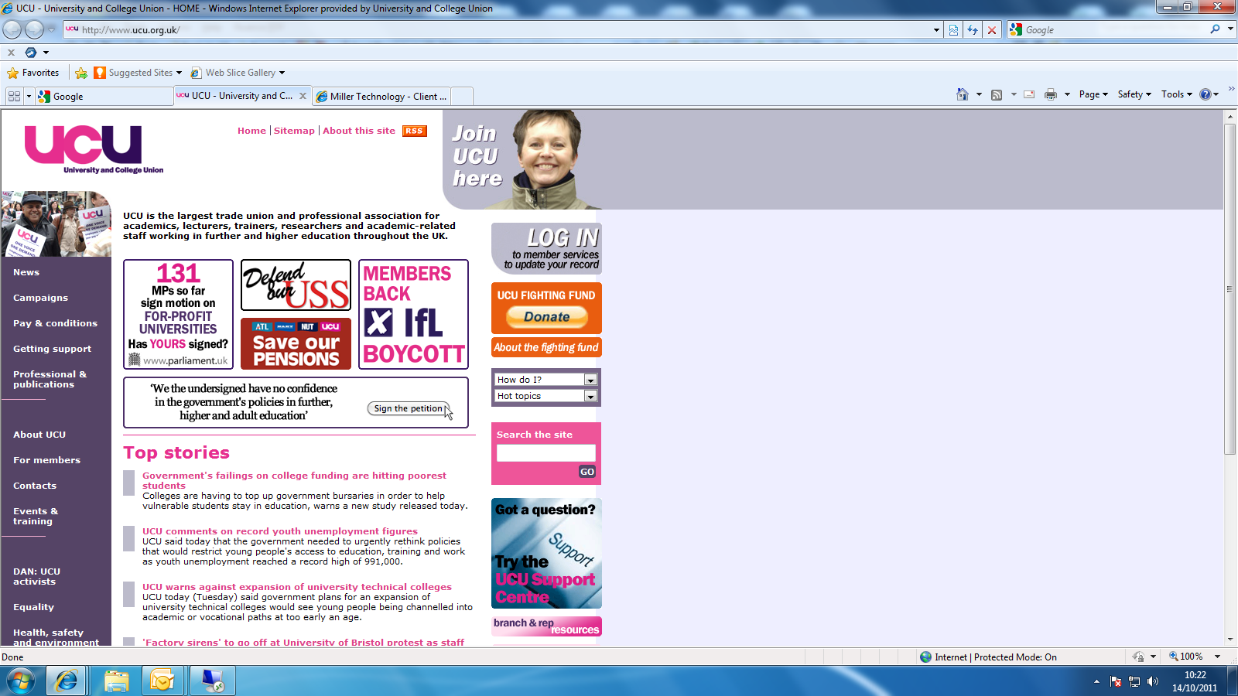

Select register first

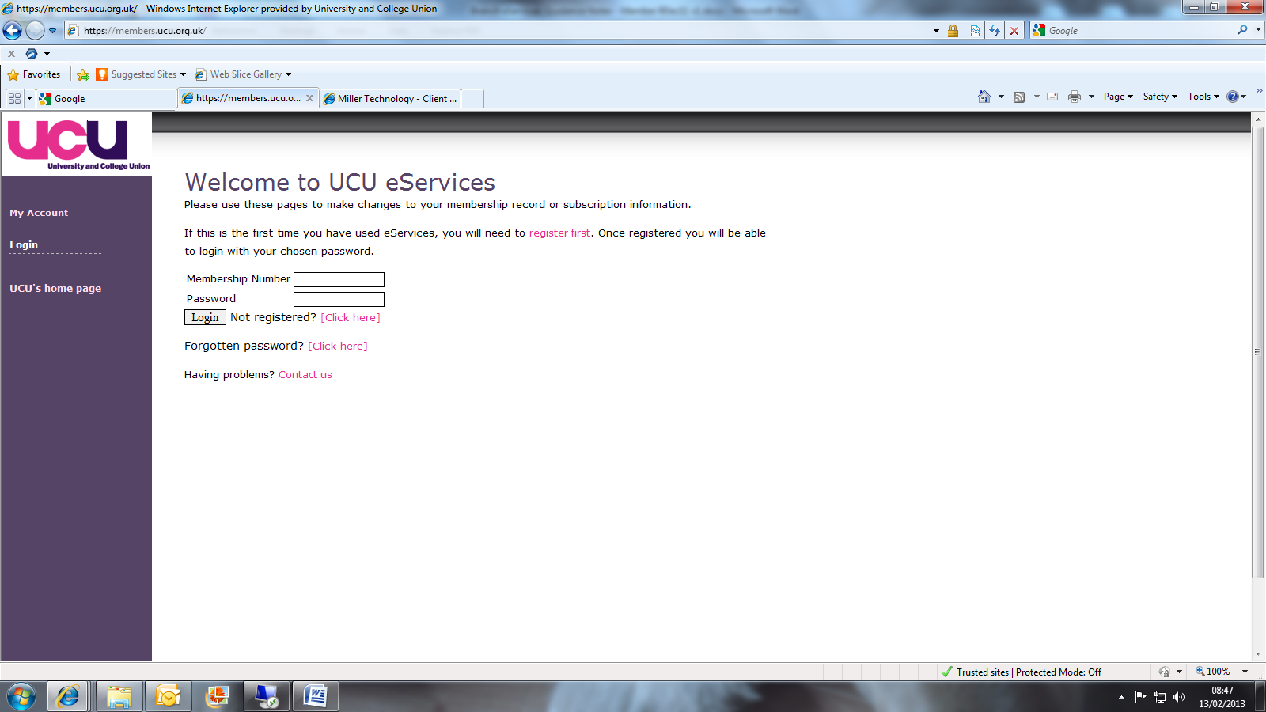

Enter your details and select register

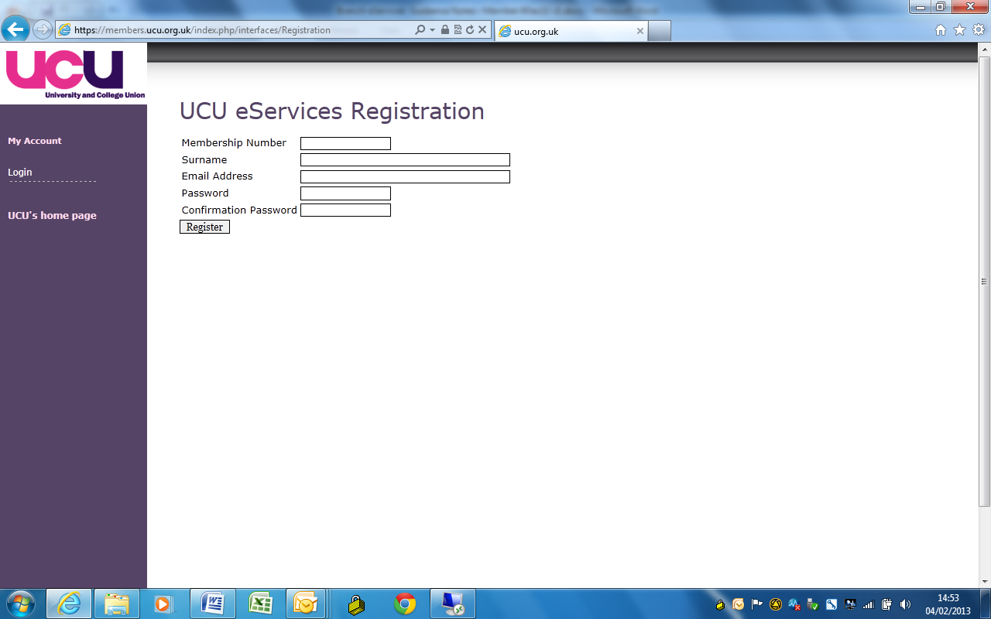

3. Access Branch eServices

Open UCU website www.ucu.org.uk

Select the log in icon

Enter your membership number and password.

Select login

4. My Personal Details Page:

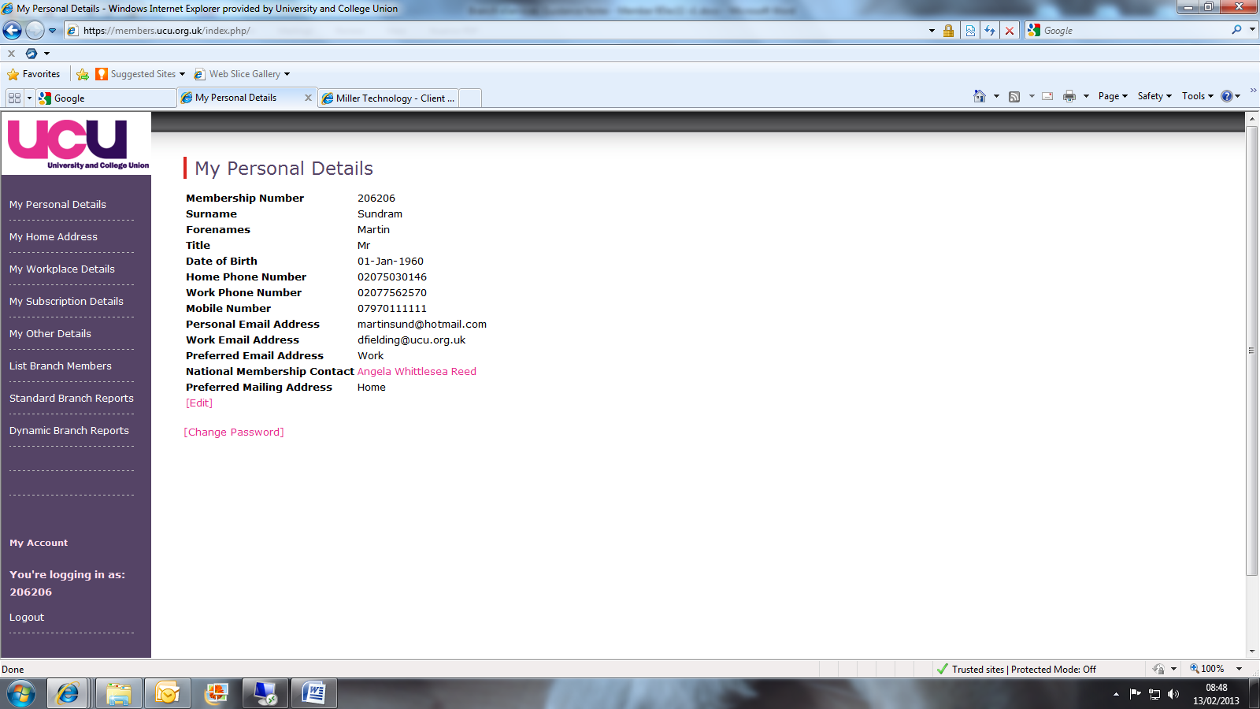

- If you need to edit any of your personal details, select edit.

Then amend as necessary and select save

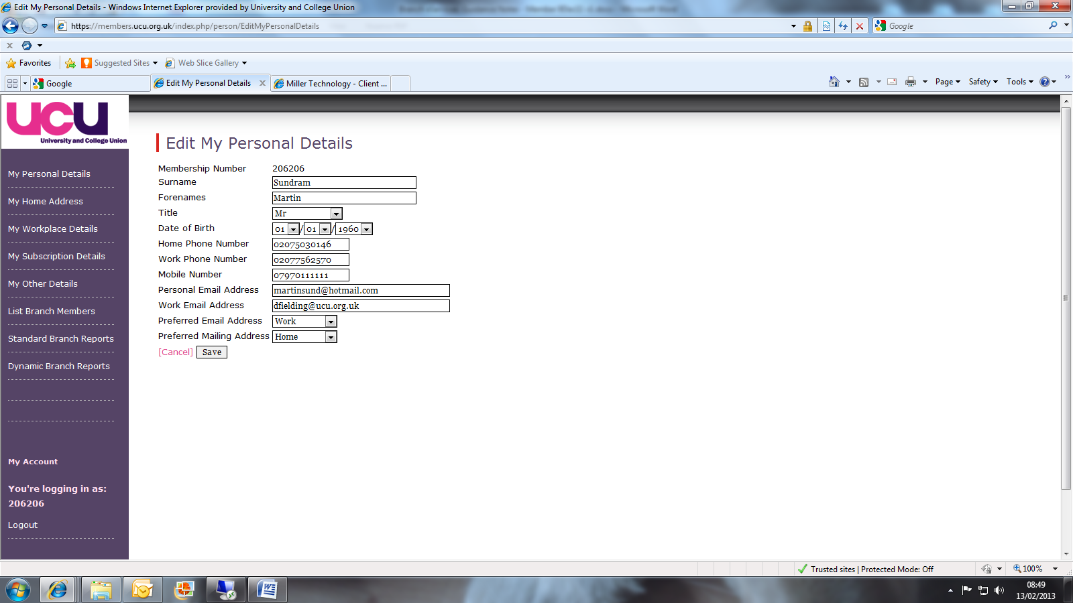

- If you wish to change your password, select change password

Enter details of current/new password and save

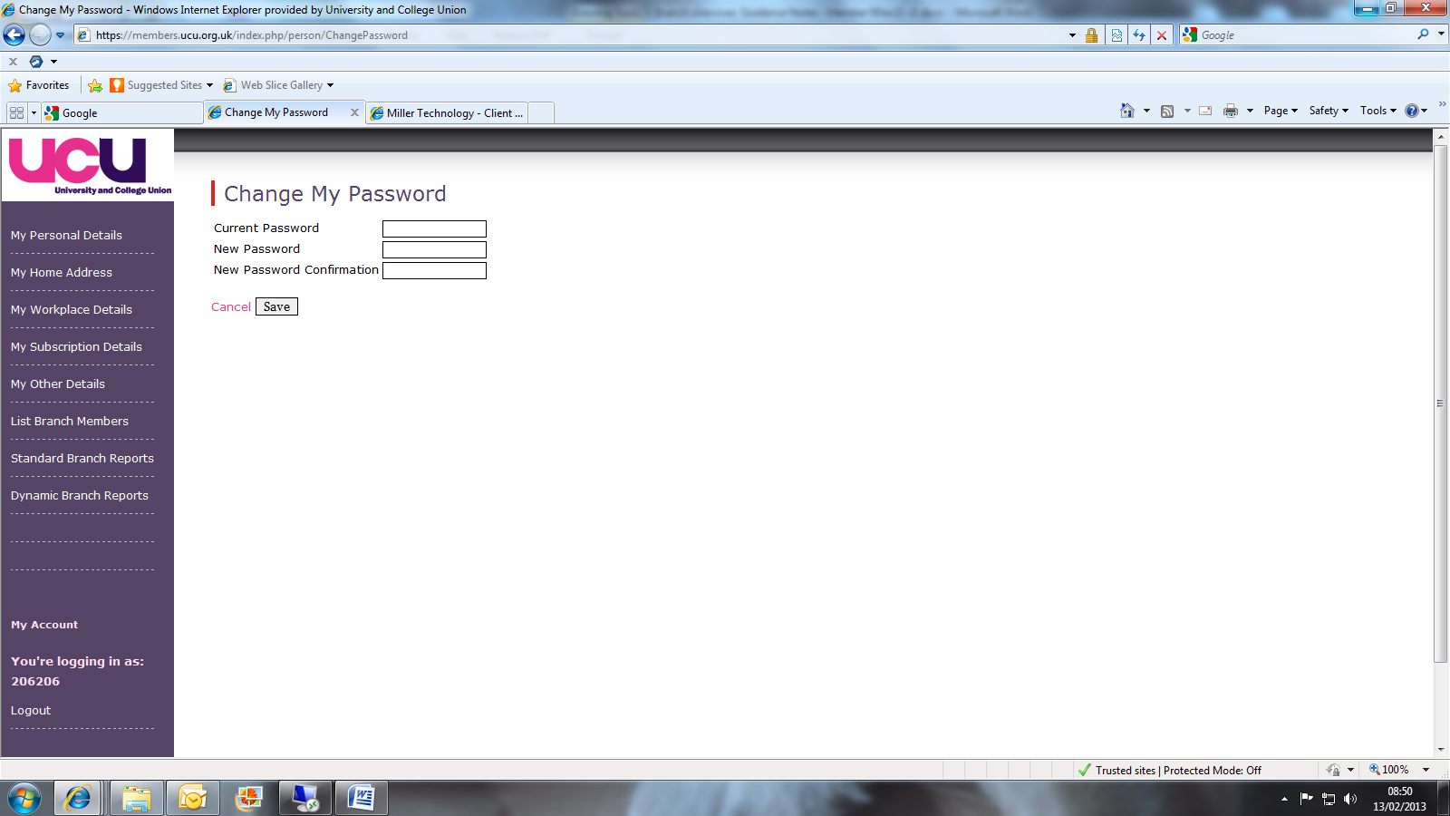

5. Member eServices

The first 5 menu tabs on the left hand side relate to Member eServices and therefore specifically relate to your own personal membership record:

- My Personal Details
- My Home Address
- My Workplace Details
- My Subscription Details
- My Other Details

These menu tabs can be viewed by any member registering and accessing Member eServices. These enable members to update their own membership details at anytime.

6. List Branch Members Page (Member Search)

This will allow you to search and run lists of specific members ie all full members, member by specific department, members that are ballot excluded etc.

Select list branch members

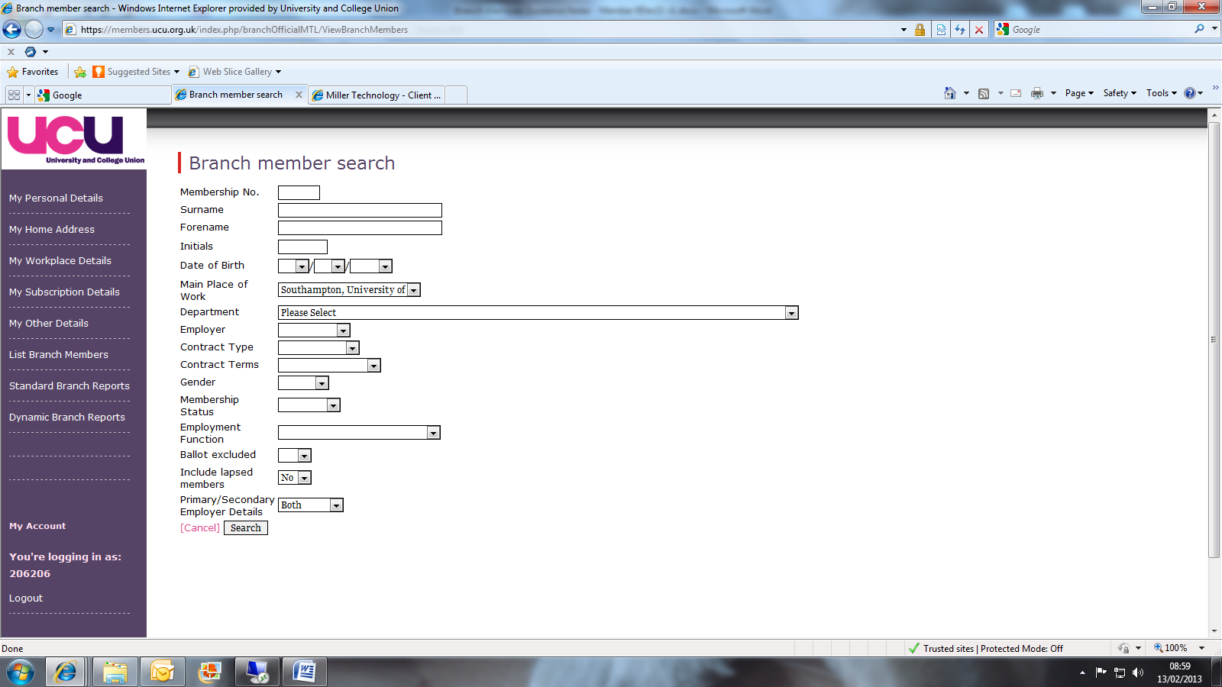

Enter your selection criteria and then select search

7. Branch Member Search Results:

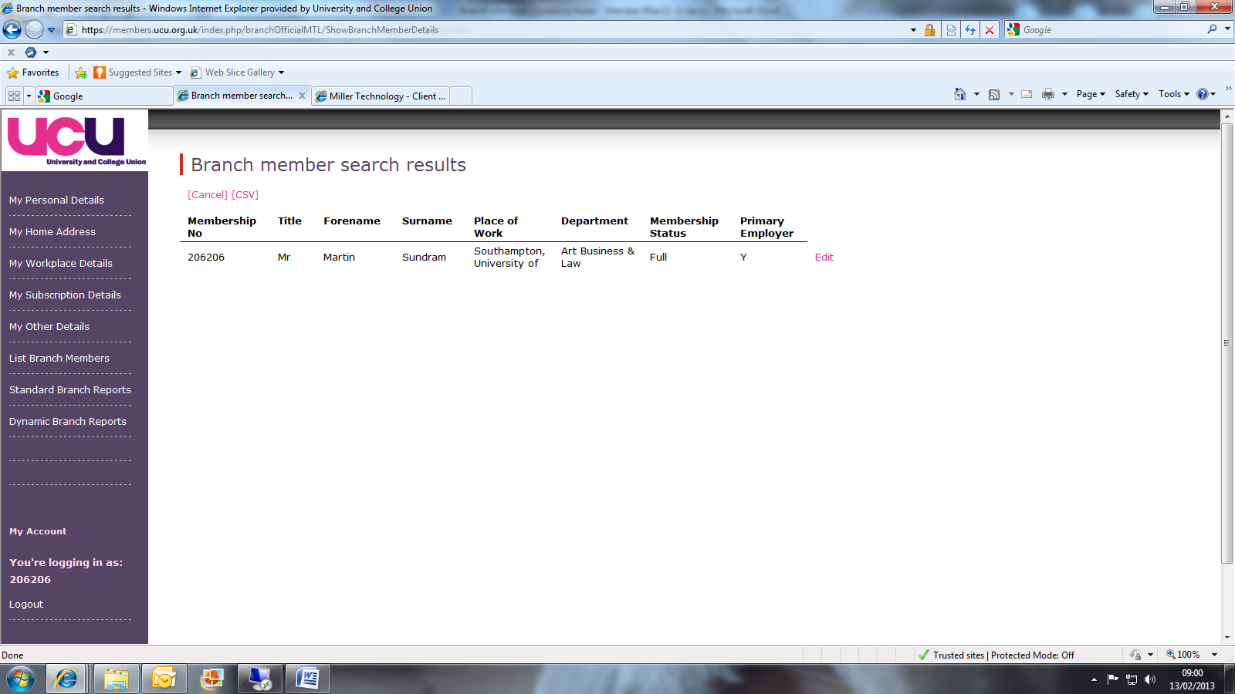

- You can edit a member’s details by selecting edit

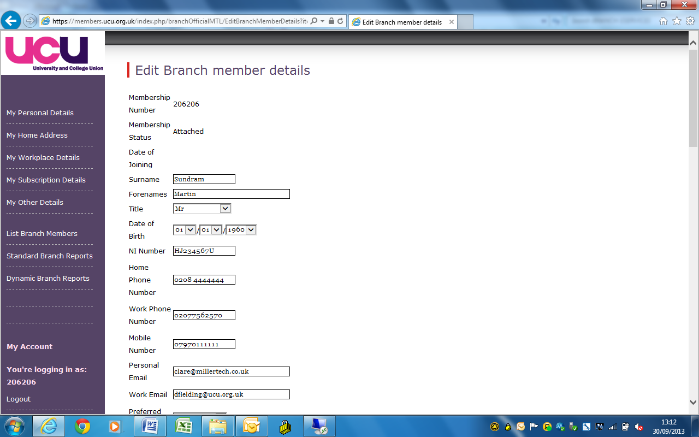

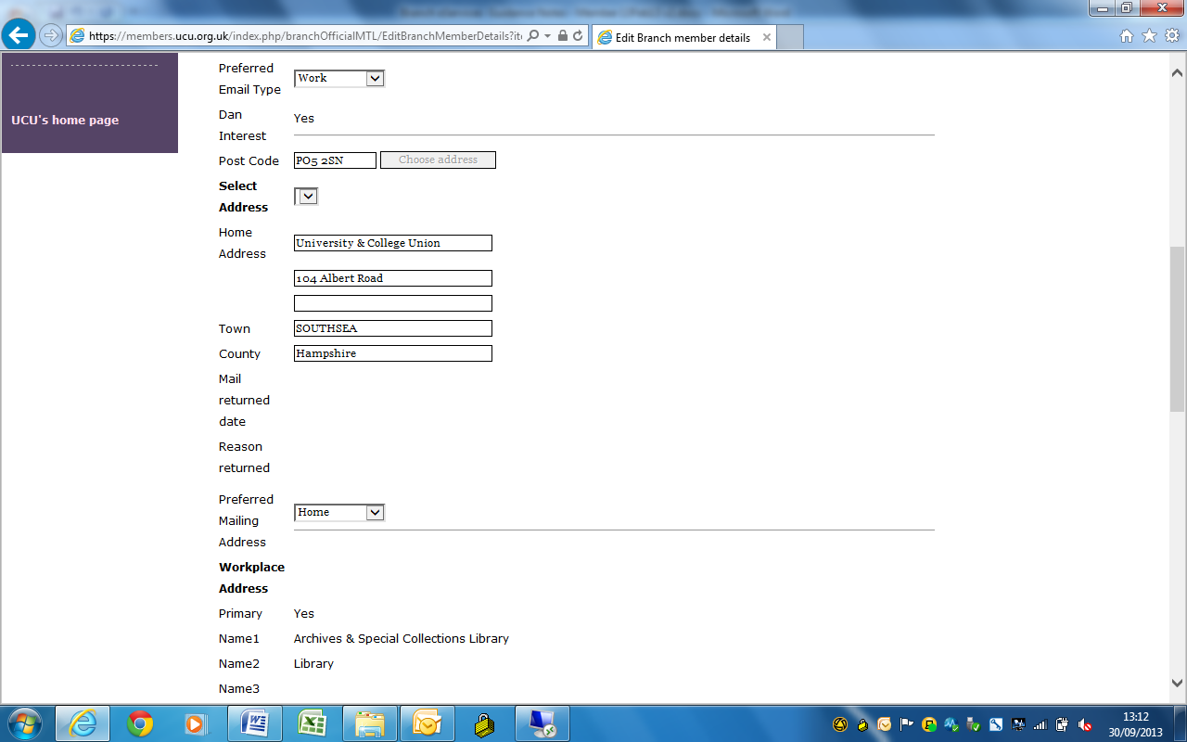

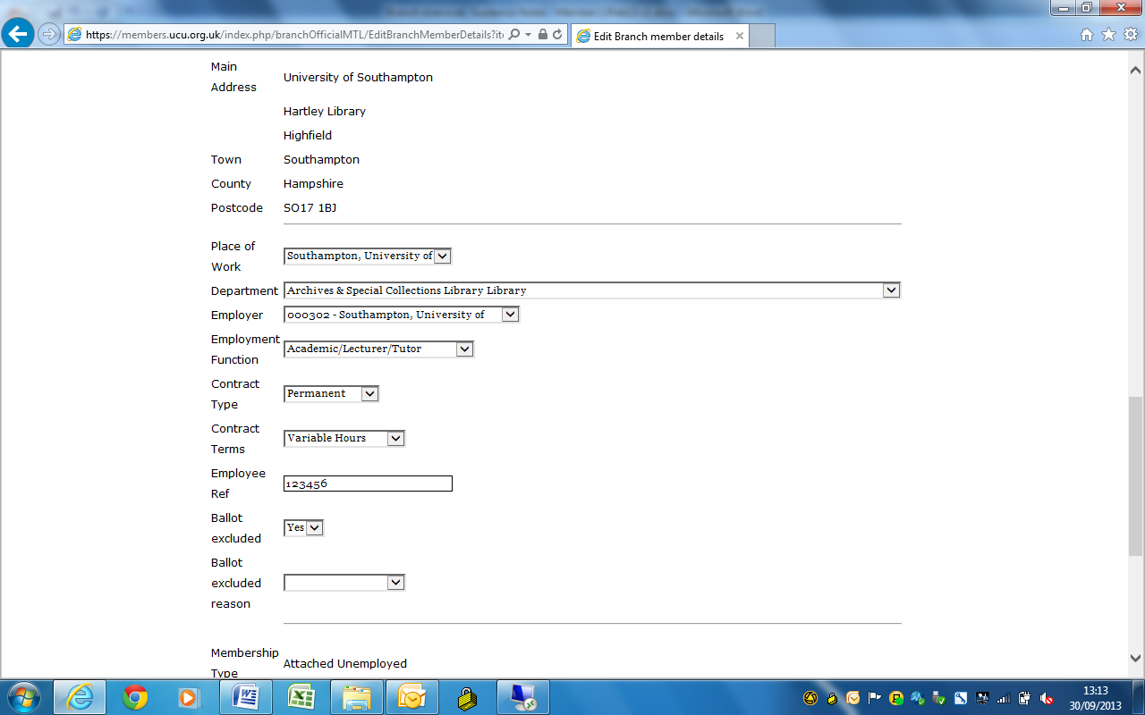

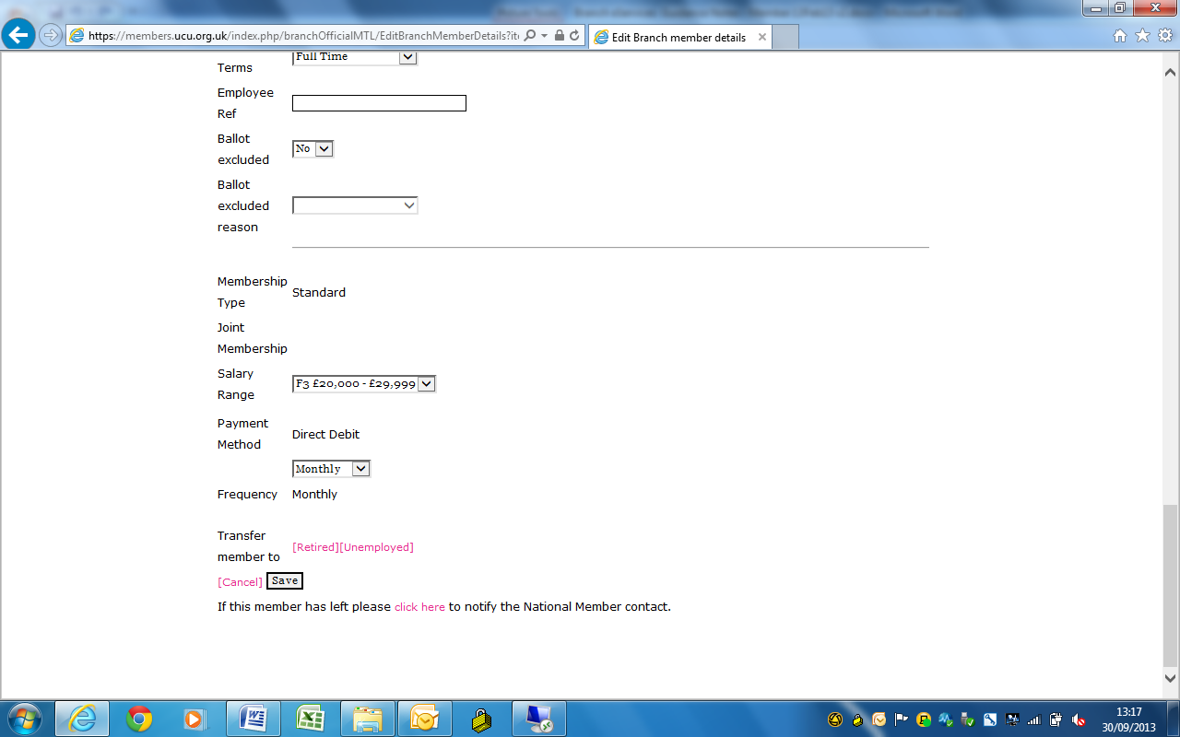

- Amend as necessary and select save

- If a member has left your branch, select “click here” to email your National Membership Contact. The member/branch details will be populated, please amend email as appropriate:

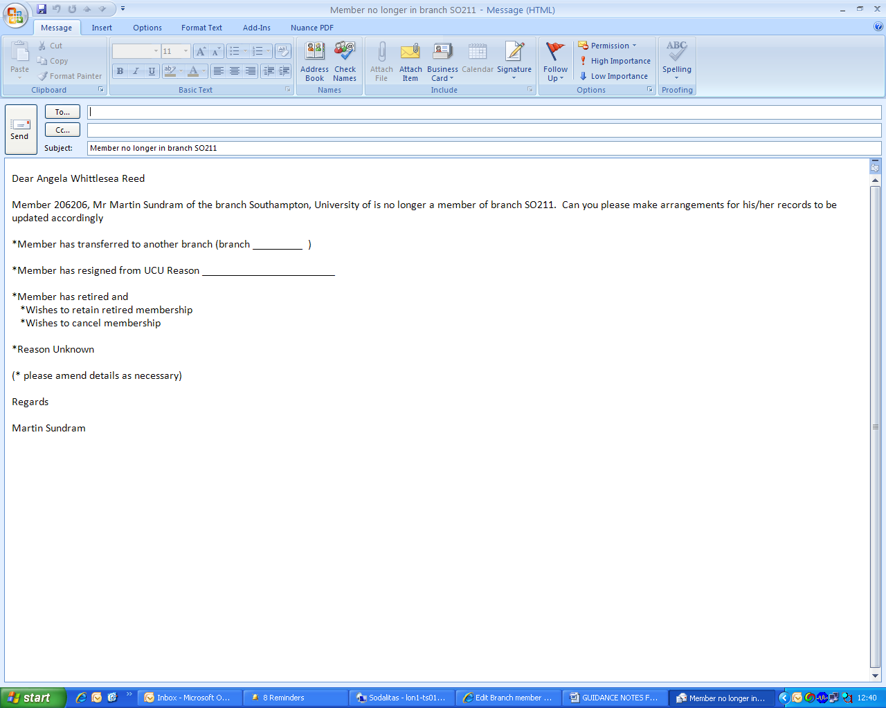

- If the member has retired or become unemployed you can transfer their membership here.

- You can run an excel/csv file by selecting csv

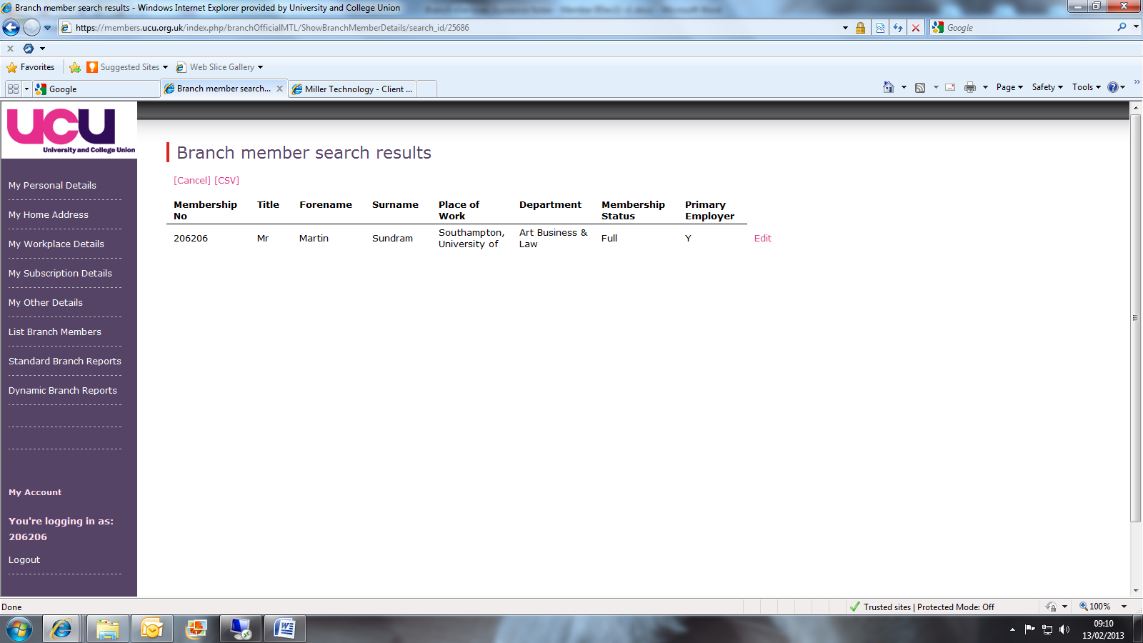

Report will produce the following fields:

- Membership Number
- Title, Initials, Forename, Surname
- Personal, work and preferred email addresses
- Branch and employer name
- Workplace name and address
- Primary employer
- Home address
- Preferred mailing type
- Employment function
- Payment method
- Dan interest
- Join date
- Gender
- Contract type and terms
- Salary range
- Ballot exclusion
- Membership type
- Lapsed reason

If you wish to manipulate the data, you will need to save as an excel spreadsheet.

8. Standard Branch Reports

Select Standard Branch Reports

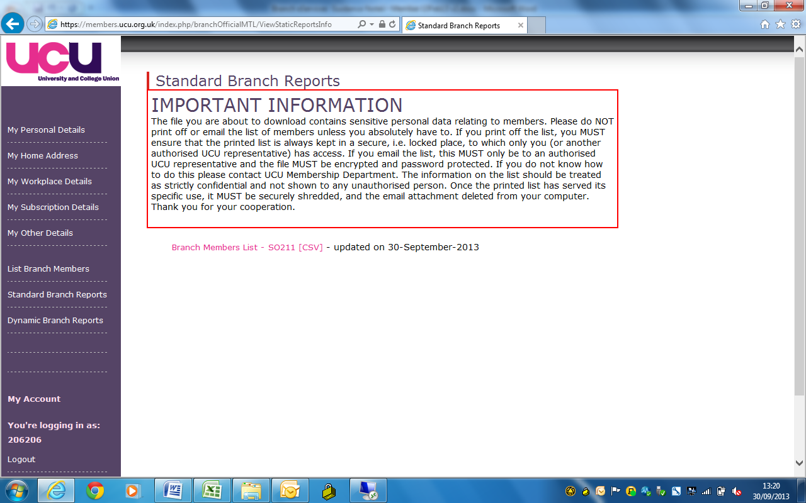

Select Branch Members List and this will produce a full membership list in excel/csv with the following fields:
- Membership Number
- Title, Initials, Forename, Surname
- Personal, work and preferred email addresses
- Branch and employer name
- Workplace name and address
- Home address
- Preferred mailing type
- Employment function
- Payment method
- Dan interest
- Join date
- Gender
- Contract type and terms
- Salary range
- Ballot exclusion
- Membership type
- Primary branch

If you wish to manipulate the data, you will need to save as an excel spreadsheet.

9. Dynamic Branch Reports

Select Dynamic Branch Reports

To be used to queue a new joiners and leavers reports.

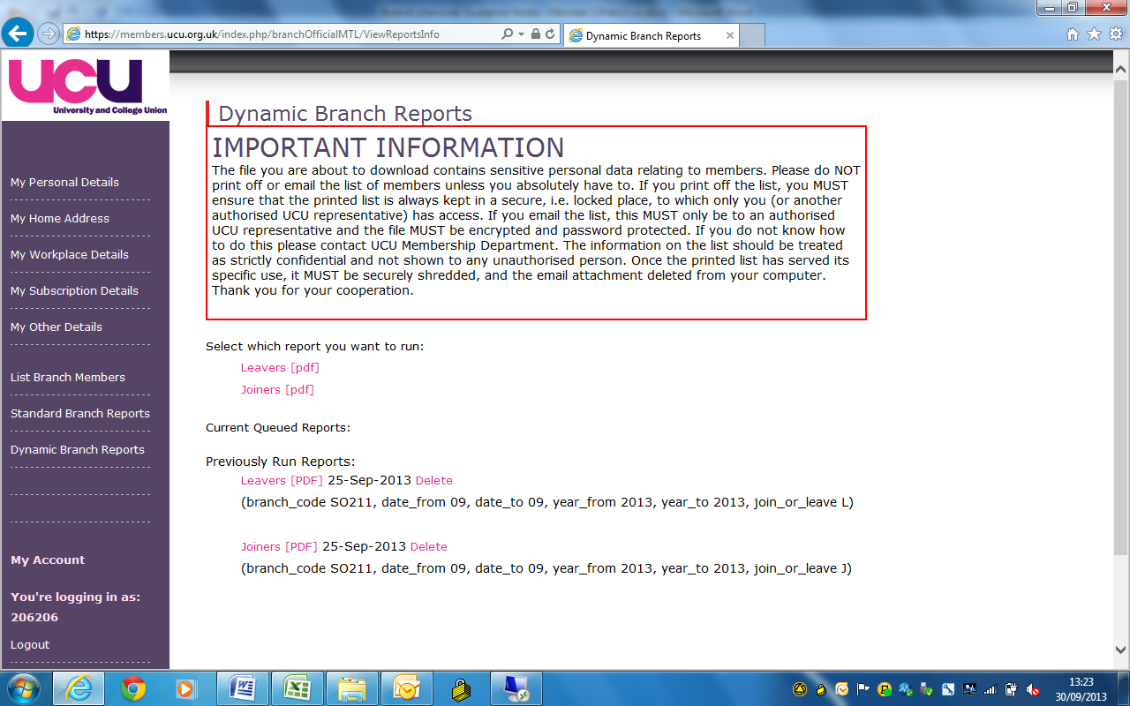

Select report required, joiners or leavers

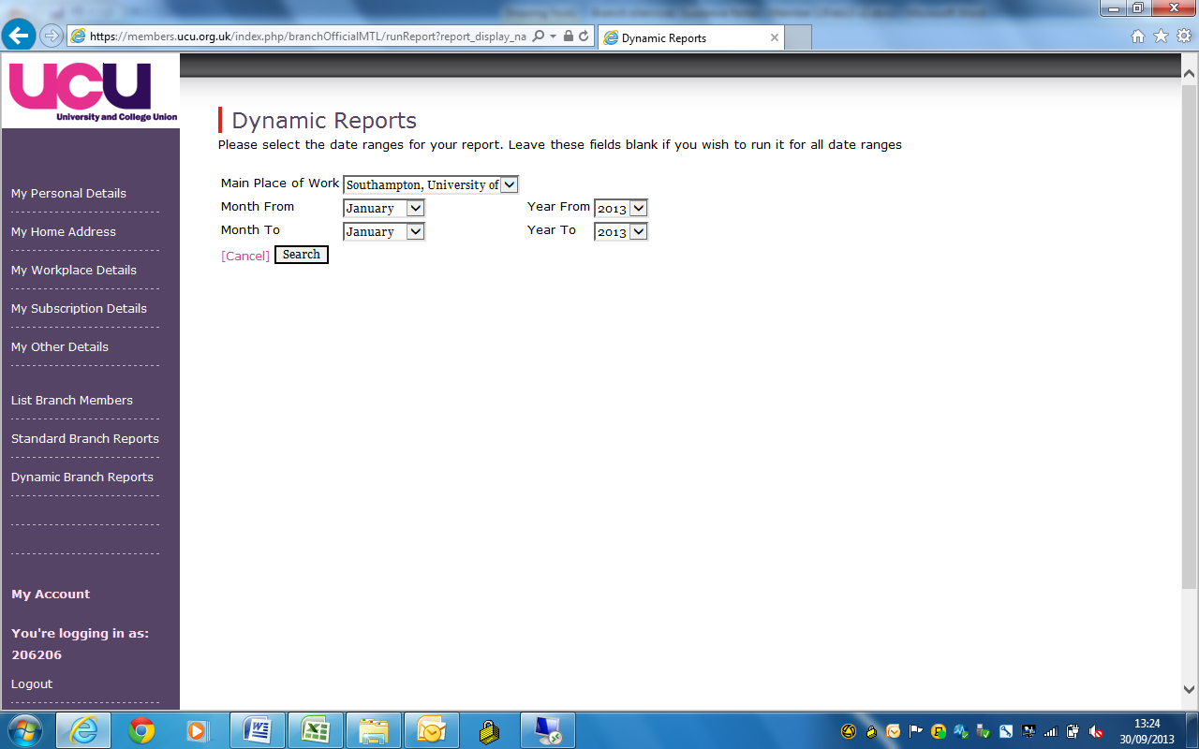

Select period you wish to cover. Select search

Report will then appear in the queue

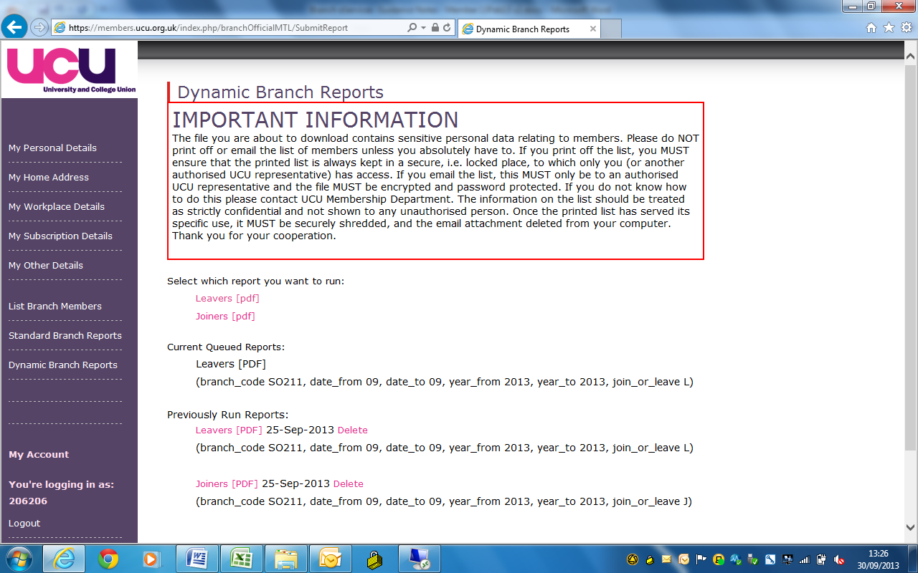

It will take a while for the report to run and be ready to view. Once ready, the report will show as a link. Double click on link to open report.

The joiners report contains the following information:

- Membership number
- Name
- Gender
- Email address
- Workplace
- Join/transferred in date
- Branch transferred from

The leavers report contains the following information:

- Membership number
- Name
- Gender
- Email address
- Workplace
- Lapsed reason
- Lapsed/transferred out date
- Branch transferred to

You can view previously run joiner or leaver reports. They can be deleted if no longer required as they can be re-queued at any time.

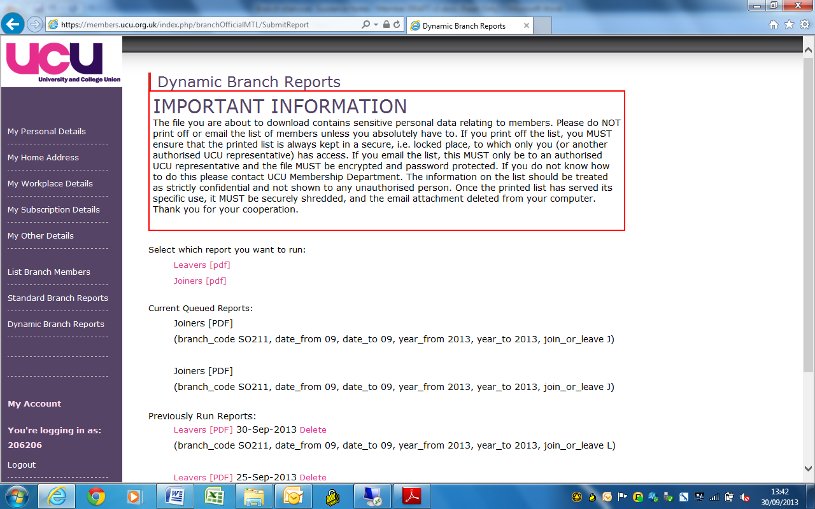

10. Logout

Always log out when not in use.

Select logout

11. Useful tips:

- Throughout the system, you can go back to the previous page by selecting “cancel”.

