In this newsletter
1. 5th October branch meeting
2. More information
3. Report on Prison Education
4. At The Office; the regional team
5. Trade Unionists in Torbay; anti austerity march

6. Knowledge is Power: #LoveFE rally Plymouth
7. Book Corner: All in a Day’s Work.
8. Campaigns and Causes.
9. The role of Retired members – an opportunity to get involved in recruitment.
10. Alison Hayman campaign.
11. Protect the Right to Strike – Francis O’Grady, TUC.
12. NPC Lobby of Parliament 4.11.15
13. Torbay & South Devon TUC news

No.9 September 2015

Newsletter

South West Retired Members Branch

1. Branch meeting
Monday 5th October 2015
12.00 a.m. – 2.30 p.m.
Still The Enemy Within.
Extracts from the film with a discussion. Venue: UCU Office. Labour Party Rooms
26b Clifton Hill, Exeter EX1 2DJ
A buffet lunch will be provided if you let us know a week in advance. ucu.swest@gmail.com

2. More information and news can be obtained from these websites. We suggest you have a browse.
UCU National Website: http://www.ucu.org.uk
AgeUK: http://www.ageuk.org.uk/
68 is too late: www.68istoolate.org.uk
National Pensioners Convention (NPC): http://npcuk.org

3. Report on talk on prison education by Philippa Davey - UCU regional support officer ( 8th June 2015 )

Like other public sector services the prison education service has seen some dramatic changes in recent years. Financial cuts, contracting out and privatisation all started under the last Labour Government. In July 2005 OLASS, the offender learning and skills service was introduced. Education providers now bid for the contract to manage prison education departments on a three-yearly basis. The South West Region is fortunate in having just one provider to deal with - Weston College. This is an advantage for UCU as it has only has one employer to negotiate with. In others regions UCU members have had up to four employers, each with a different set of terms and conditions, as we have now reached tendering round OLASS 4. UCU has described the prison education system as "failing" because of the constant re-tendering for teaching contracts. Some members have gone through the stressful process of TUPE to a new management system four times.

The vast majority of prison lecturers are part-time, poorly paid and do not have secure contracts despite the fact that prison education is by far the most difficult sector of post-school education to work in. The physical environment creates problems. Teaching staff working in prisons rely on prison officers to gain access to locked rooms and are not able to move freely around their workplace. For security reasons they do not have access to email which makes organising difficult. Prison Governors have wide powers and set the tone of the institution's regime. Members can feel victimised and harassed and it seems that appropriate action is not always taken. Lecturers have been dismissed in young offenders institutions for not controlling classes when working under very difficult conditions.

The UK has the most privatised prison system in Europe and prisons here have been overcrowded every year since 1994. The budget for prison education has been severely cut and further cuts are proposed. UCU figures suggest that lecturers in prisons earn £15,000 a year less than equivalent staff in FE colleges. The important work of our members in prisons is largely unacknowledged. It is clear that prison education staff do not receive the support or respect they deserve. Despite being staffed by a highly motivated, well-qualified and experienced lecturers prison education has a low status.

Our members play a key role in the rehabilitation of prisoners and the prevention of re-offending but are hampered in their work by cuts to courses. The curriculum available for prisoners has shrunk. Prison education is increasingly focused on vocational courses and there are less opportunities to engage in academic or liberal arts courses which might engage prisoners and broaden horizons. Prisoners are not receiving the help they need to return to life outside prison. Over 45% of adults released from custody are re convicted within a year of release at a cost to the economy of £15 billion per year. Prisoners who reported having a qualification were 15% less likely to be re convicted a year after their release and more likely to find secure accommodation and employment.

The type of work our members undertake and working conditions vary through the region. In overcrowded local prisons such as Exeter the large number of remand prisoners means there is little time for education and few short stay prisoners are in the settled frame of mind needed for courses. It is difficult to engage prisoners who have sentences of less than one year. In an open prison such as Leyhill prisoners may go out of the prison to work. The focus is on vocational courses like an adult apprenticeship to facilitate a gradual return to employment on release. Philippa described the successful work being done at Eastwood Park women's prison in Gloucestershire where a profitable soap making business has been set up. Conditions are very different for lecturers at The Verne in Portland which is now a training prison for adult males. 60% of the prisoners are foreign nationals and 50 different nationalities are represented. Here economic refugees, who perhaps have breached immigration laws, value education and are enthusiastic to learn. Philippa ended by asking if members could contribute any unwanted books for prisoners and materials such as duvet covers that can be used for sewing projects. She can be contacted at the Exeter SW Region office. exeter@ucu.org.uk
Ruth Amias SWRMB

Postscript: Michael Gove, the justice secretary, has taken the first steps in his plans to introduce an “earned release” scheme for prisoners in England and Wales by announcing a major review of education provisions in jails.
Rules restricting the number of books a prisoner can have been overturned by Gove from 1st September. This is one of Mr Gove's first key changes to prison policy since being appointed as justice secretary.

4. At The Office.
The regional office is at Exeter; we have our meetings there and we often see the staff on our visits. I asked if they would each provide a piece for our Newsletters. Becca Richards, David O’Toole and Philippa Davey featured in the May newsletter.
Nick Varney. I am the regional official for an extended SW region which includes institutions in Oxfordshire, Wiltshire and parts of Berkshire as well as the SW region as we all know it. As such I have overall line management responsibility for the industrial and organising work in our region, a role that could not be carried out without the dedication shown by all the other members of the team.
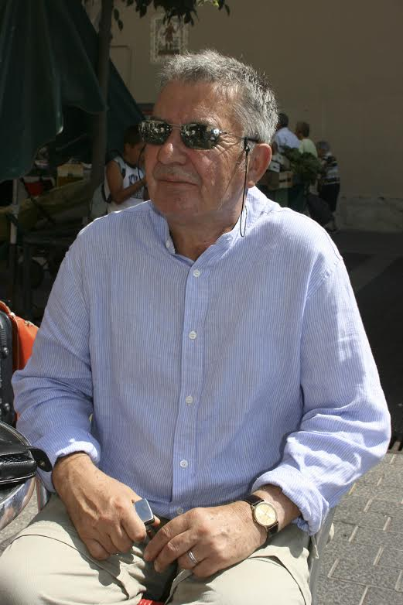
Catriona Scott I am a regional support official, with responsibility for supporting a range of branches across the region. Similar to other officials in the Exeter office team, much of my work revolves around providing bargaining, campaigning and negotiating support to branches in relation to collective issues, and providing advice and training for UCU reps supporting members in their own branches. Colleagues in the team contribute enormously to the effectiveness of the work that I do.
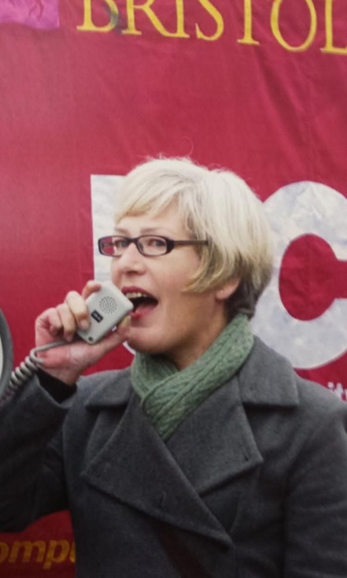
Here is the South West Region website.
http://southwestregion.web.ucu.org.uk/
5. Trade Unionists in Torbay join hundreds on anti-austerity march
Trade Unionists joined the Torbay 3 Towns anti austerity walk on the 18th July. The GMB presence was noticeable with a number of flags prominent amongst political banners and slogans. The FBU were also present, and a speaker from the union spoke on Preston Green of how the government were attacking his union and the safety implications for fire fighters and the general public.
The event was well received by the passing public who waved in support or sounded horns on their cars as the march made its way from Brixham to Torquay. Liza Sentence SW RMB

6. Knowledge is Power - #LoveFE Rally, Plymouth, June 27th 2015 The day of the Defend FE Rally was a beautiful sunny day, one of the few so far this summer. It was also Armed Forces Day in Plymouth, an event which attracted large crowds to the Hoe. Fortunately, the gathering point for the rally was in the middle of the route from the City Centre, and people who streamed past on their way to support those who defend our country, will have caught sight of the banners and taken, and maybe even read, the leaflets calling for another kind of defence.
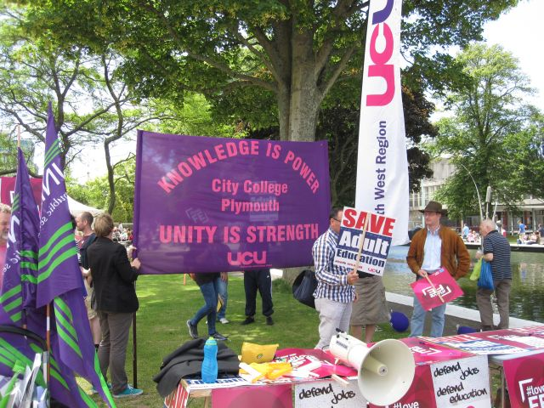
The rally in Plymouth was small, but noisy, and received some good press coverage. Speeches were given by representatives from the City College Plymouth UCU branch and Unison. The Plymouth Poet Laureate read one of his poems. I stood next to a woman who throughout her life had enjoyed learning a variety of skills by doing adult education courses, and was deeply saddened that these opportunities were no longer available to future generations.
Two Plymouth City Councillors (Labour) were amongst the crowd, and as we started on a short circular march I caught sight of our Conservative MP, Oliver Colville. He was standing a short distance way, in the shadow of the Civic Centre, and I don’t think he wanted to be seen. Could he have felt ashamed? Pat Mee SWRMB
7. Book corner

8. Campaigns and Causes.
All members for whom UCU Head Office has an email receive a weekly Campaigns update. If you receive this newsletter, but not the weekly updates from Head Office it, then let us know and we will ensure you are on the HO circulation list.
Ucu.swest@gmail.com

9. The Role of Retired Members.
Recruitment of members has always been a priority. However with the savage cuts in FE and potential for the same in HE, replacing lost membership is now critical. It may be that we, as retired members are able to help.
……………….
From Nick Varney Regional Support SW The union has designated w/c 16th November 2015, w/c 22nd February 2016 and w/c 25th April 2016 as recruitment weeks when all our focus will be on organising activities across the region.

The actual activity during the first of these weeks is still in the planning stage with supporting materials being developed at Head Office. It is hoped that all staff, branches, and of course retired members will support this initiative. I will be clearer as to the actual activity and where we need help in a couple of weeks and I will ensure that the SWRMB is in the loop re information

Aside from these specific weeks Dave O’ Toole our Regional Branch Development Organiser is designing a schedule of activities and I am sure he will contact you once he identifies where the support of the SWRMB would be appreciated.

10. Alison Hayman campaign.

Following the branch meeting of 8th June, I wrote to UCU Bristol University .

I am writing as the chair of the South West Retired Members branch. Though retired, our 200 plus members continue to have an interest in local and national campaigns - we may be retired but we still have a fire in our belly.

Our membership includes many whose working life was at Bristol University, so Alison's case is of great interest.

At our recent branch meeting (June 2015) we had a report from our delegate to Congress 2015. It was decided that, as chair, I would follow up the situation regarding the motion, which was carried, and offer support to the UCU campaign.

We understand that FOI requests made in the course of Alison’s case show that Alison was not treated equally to other staff who secured no grant funding; and that, as is often the case in these situations, there appears to be a gender bias.

UCU Bristol responded with thanks. There is more information on the petition which is still live. https://campaign.goingtowork.org.uk/petitions/reinstate-alison-hayman

11. Francis O’Grady TUC
Protect the Right to Strike: join the campaign
In a nutshell, the government's Trade Union Bill would mean:
- employers were able to use agency temps to replace striking workers
- restrictions on pickets and protests that threaten freedom of speech
- attacks on union reps in the public sector
along with lots more unnecessary red tape, tying up unions.
Taken together, these will undermine our basic right to strike. And that will tip the balance in the workplace in favour of employers.
We need your help to defeat this bill.
Join me in the campaign to protect the right to strike.

People win when we stand together. Stand with us.
Thanks for your support, Frances O'Grady,
TUC General Secretary.

12. NPC call lobby over care and pension for 4th November 2015

The NPC has called a national Lobby of Parliament for Wednesday 4 November 2015, with a rally in Committee Room 14, House of Commons from 1-3pm. There will be a range of speakers and government ministers will be invited to speak.

SOCIAL CARE. Our care system has collapsed. Widespread rationing of services, low paid staff and poor standards of care have all caused the crisis. Everyone now accepts that health and social care need to be integrated. This could be achieved with the creation of a National Health and Care Service, funded through taxation and free at the point of use.

PENSIONS. The UK pension system is totally inadequate to deliver a decent standard of living in retirement to everyone. The state pension is among the worst in Europe, occupational pensions are in decline and the new state pension system will mean future generations have to work longer, pay more and get less. We need a living state pension that takes everyone out of poverty and gives them dignity in retirement.

For more information contact:
NPC Walkden House, 10 Melton St, London NW1 2EJ. Tel: 0207-383-0388 / www.npcuk.org

13. Torbay and South Devon TUC.
We are affiliated to the TSD branch of the TUC and Liza Sentance is our delegate.

18th August, 2015. Trade Unionists were joined by members of the Green Party, Labour Party and the South Devon People’s Assembly in a protest outside Torquay Town Hall at plans for trial closures of Connections offices in Brixham and Torquay.
Torbay & South Devon TUC President, Paul Raybould, spoke at the meeting detailing concerns of Trade Unionists, which are shared by the wider public. In a prepared speech Mr. Remould said, ‘Our organisation has some 7.500 affiliated members via various Trade Unions in the Bay in both the private and public sector. We have many members that are retired, or disabled or on low wages. They would be disadvantaged by having to use one central site in Paignton’.
The local TUC President spoke of how the disabled would be affected. ‘For the disabled in wheelchairs’, he said, ‘To have to travel by bus or train is more considerable effort and may mean rearranging carers for and aid the journey and will obviously incur considerable cost’.

Paul continued to highlight concerns of both retired workers and those on low wages if the offices are closed. ‘For retired members, again the travel, if living in Brixham or Torquay is not justified, as Connections offices in their own towns provide a local service. Also many are not computer users, so embarking on a trip of 5 to 10 miles and then to be asked to fill in an online application for housing benefits is completely unfair and unacceptable’
Speaking on behalf of the low paid workers, Mr. Remould had this to say. ‘Low waged members who rely on Connections in Torquay and Brixham would have to find bus, taxi or rail fares that would not be refundable. Once again this is from a Mayor who support of low pay and opposition to the Living Wage is well documented’.
Mr. Raybould pointed out Torbay & South Devon TUC had asked for guidance on the proposed trial closures. ‘We held an emergency executive meeting on hearing of the ludicrous proposals’, he said. ‘A decision was made to seek guidance. Correspondence was written to the Chair of Overview and Scrutiny and also to Mayor Oliver to reconsider what is his decision. We received no response’
You can read the full report at http://torbaytuc.weebly.com/news/local-tuc-president-speaks-out-against-connections-closures

For more information
please contact ucu.swest@gmail.com
or contact the officers here:

South West Branch officers and committee

Chair: Jo Corke ucu.swest@gmail.com
Vice Chair: Liza Sentance, lizasentance@hotmail.com
Secretary: Pat Mee Patriciamee@sky.com
Regional rep: Margaret George mmargaretg@gmail.com
Treasurer: John Daniell john.daniell@btinternet.com
Membership: ruthamias2000@yahoo.co.uk
Environmental Rep Liza lizasentance@hotmail.com

