

**No 5** ⚫ **November 2012**

# Contents

**UCU is committed to campaigning against xenophobia, racism, anti-Semitism, homophobia and Islamophobia. We affiliate to Unite against Fascism and Hope not Hate**

**EDL banned in Walthamstow**

**Holocaust Memorial Day 2013**

**Other new in equality**

**Future events**

**In the press**

**True Brits: A Hope not Hate Report**

**Materials and resources**

**EDL banned in Walthamstow**

Last we informed you that policing Minister; Damian Greene had banned the EDL from marching through the London Borough of Walthamstow. We welcome this move by the minister and see this as another victory in the fight against racism.

As no restrictions were placed on anti-fascist groups demonstrating, UAF and We are Waltham Forest organised a victory rally on Saturday 28 October. The event was attended by over 1000 residents including MPs, trade union activists and members of faith and community groups.

Weyman Bennett, joint National Secretary of Unite Against Fascism said:

***“It is the mass mobilisation of people that stopped the EDL last time and it is the mass mobilisation of people that has forced the authorities to exclude them from Walthamstow. This method of unity and mobilisation stops fascists and racists.”***

The event passed with no incident.

Unite Against Fascism has produced a factsheet explaining the dangers of the English Defence League. Download the [EDL factsheet](http://uaf.org.uk/wp-content/uploads/2011/11/EDLfactsheet1.pdf) here

**Holocaust Memorial Day 2013**

Holocaust Memorial Day is observed annually on 27 January. It is a day where we share the memory of the millions who have been murdered in the Holocaust and subsequent genocides in Cambodia, Rwanda, Bosnia and Darfur in order to challenge hatred and persecution in the UK today.

UCU is encouraging branches and local associations to organise events locally to mark the day and will be providing the following materials to assist:

* Award winning wall chart
* Anti-Semitism leaflet
* Booklet of personal testimonials of UCU members and other speakers who have attended past events
* Book / film list

We are also exploring the possibility of producing a short film for the UCU website explaining why it is important to mark the day.

**We want to hear from you!**

Please keep us informed of any activity your branch is organising to mark this day. Please send full details to [eqadmin@ucu.org.uk](mailto:eqadmin@ucu.org.uk) and we will share this with the wider UCU membership.

**Remembering the past and facing the present**

UCU Regional Support Official for South West Region, Philippa Davey, recounts her experiences of visiting Auschwitz in 2011 and standing up against the EDL in her home town of Plymouth.

In January 2011 my daughter and I went to Auschwitz on Holocaust Memorial Day. The camp was surrounded by armed Special Forces, helicopters and military vehicles as the Polish and German Presidents and other dignitaries were laying wreathes.  It was snowing.

It was really eerie as you could almost imagine the troops were the SS and there were also a number of camp survivors wearing neck scarves in the "pyjama stripes" of the uniform of prisoners.

Meeting some of the prisoners was a humbling experience and I spoke to a Polish political prisoner who was also a trade unionist. He was arrested and sent to Auschwitz for helping Jews to hide and escape the ghettos. He said he never gave it a second thought that he would protect his neighbours and community. My daughter and I said that we would likely be in the camps as we are both Trade Unionist and my daughter is gay. We both said we would like to think we would stand up against racism, fascism and homophobia. He said that was good news as people needed to stand up to the fascist threat that still existed and we promised we would make sure that we did.

In May 2011 I was elected as a Labour Councillor in Plymouth. At the end of June 2011 the EDL planned a march through our City Centre and as a UAF member I was asked to approach other Councillors and MP's and ask them to sign a statement renouncing the EDL and supporting a peaceful multi cultural event on the same day. I was proud to do so and asked Councillors and MP's from both Parties to do so. The statement described the EDL as racist and cited a recent racist attack that members had been involved in.

Initially our Group Leader and Councillors agreed to sign and for this to go into the Press. About a week before the march I received a phone call from our Group Leader saying that the Council Officers had advised we do not sign as we could be sued for saying the EDL were racist and we could be personally held responsible. It was a difficult phone call and as I had only recently been elected I was considering not signing and not continuing to pressure other Councillors and MP's.

As I walked home, feeling very upset, I remembered the promise I had made at Auschwitz.

My life wasn't at risk and all I was being asked was to sign a statement that I knew to be true, I had failed at the very first opportunity to stand up against fascism and racism and let down my community.

I rang our Group Leader back and said that I didn't care what anyone else was doing I was signing and I was signing because it was true and I was not scared by a threat to sue.

In the end our whole group signed, both MP's and some individual Tory Councillors. We attended the event, marched, spoke and spent the day with friends and neighbours. I can look myself in the eye in the mirror and when I returned to Auschwitz this year I felt I could go with a clear conscience.

I would hope that if my life or freedom was threatened I would do the same but I can see how easy it is to make the wrong decision and that is why we must speak out, we must listen to survivors and we must remember.

**Other news in equality....**

**Annual Equality Conferences 2012**

Registrations are now open for all UCU members to attend the 2012 Annual Equality Conferences. They will be held at UCU Head Office, Carlow Street, London from 10am – 4:30pm. See dates below

|  |  |
| --- | --- |
| **Women Members’ Conference Friday 9 November 2012**  **Register here:**  <https://www.surveymonkey.com/s/women-members-12>  ***Deadline for registration:***  ***Friday 26 October 2012*** | **LGBT Members’ Conference**  **Saturday 10 November 2012**  **Register here:**  <https://www.surveymonkey.com/s/LGBT2012>  ***Deadline for registration:***  ***Friday 27 October 2012*** |
| **Black Members’ Conference Friday 16 November 2012**  **Register here:** <https://www.surveymonkey.com/s/Black-members2012>  ***Deadline for registration:***  ***Friday 2 November 2012*** | **Disabled Members’ Conference Friday 23 November 2012**  **Register here:**  <https://www.surveymonkey.com/s/Disabled-members2012>  ***Deadline for registration:***  ***Friday 9 November 2012*** |

These conferences are excellent opportunities to meet other UCU members and discuss key issues affecting Black, Women, Disabled and LGBT members. They consist of a mixture of motions from branches/LA, speakers and workshops, and are central to taking forward the equality work of UCU. Delegates for these conferences are self nominating and must self-identify with the relevant equality group.

There are no restrictions on the number of delegates, but the maximum size of all conferences is 90-100. Registrations will be dealt with on a first come first served basis. Members will be registered as an **observer** (not entitled to vote on motions or nominations) if the registration form is received after the deadline date.

**Register now to help shape your union!**

**Future events**

**UCU Austerity and Equality in Multiculturalism Britain – a UCU conference**

We are in the early stages of organising a conference in response to Congress motion 18 ‘Austerity and equality’ and motion 19 *‘Defend multiculturalism, oppose Islamophobia and racism – stop the EDL’*. We anticipate that this event will take place in the New Year and will keep you informed of speakers and the date of this event. The full text of the motions is shown below:

***‘Austerity and equality’ – National Executive Committee***

*The onslaught against equalities is moving quickly. The welfare state is being dismantled at a rate of knots and most vulnerable in society hit the hardest. There is plenty of evidence that where there is more equality, societies fare better. We also know that in times of austerity excuses are made to cut back. We need to resist that argument and push hard not only to keep the gains we have made but to progress.*

*The same applies for our members. We need to be vigilant and not allow employers to bargain away equality gains in the workplace and or, to regress on equality in the curriculum and in the classroom.*

*To this aim Congress calls on the NEC to support and organise for a joint education TU event on progressing equality in education and in the workplace and to host this event in the autumn.*

***‘Defend multiculturalism, oppose Islamophobia and racism – stop the EDL’ – Tower Hamlets College, Westminster University (Regent)***

*Congress notes:*

1. *The positive role post-16 education plays in promoting multiculturalism.*
2. *David Cameron's Munich speech claiming that 'multiculturalism had failed', which coincided with an EDL march in Luton.*
3. *The bombing and massacre of 77 people in Norway in July 2011, an attack which targeted the labour party youth wing.*
4. *The terrorist Anders Behring Breivik had links to the EDL.*
5. *In September the EDL attempted to march on the East London Mosque in Tower Hamlets.*
6. *The EDL were stopped by 10,000 people - mobilised by East End United and Unite Against Fascism.*

*Congress believes:*

1. *The EDL is a racist and fascist organisation with links to the BNP.*
2. *That united community campaigns of religious communities, trade unions, socialists and labour parties can defeat the EDL.*

*Congress resolves to:*

1. *Encourage members to support mobilisations against the EDL.*
2. *Organise an autumn conference to follow up on last year's successful 'Celebrate Diversity, Defend Multiculturalism, Oppose Islamophobia and Racism' conference.*

**Race, racism and resistance on film**

As part of the Generation 3.0 project, Runnymede is organising a series of lectures and panel debates on race, racism and resistance in the UK on film and broadcast media. The events have been developed for students interested in film and broadcast media and will take place in Birmingham, London and Manchester.

Each event has been tailored to the specific local histories of the host city and panellists include notable public figures such as Riz Ahmed, (Ill Manors) and Himesh Patel (EastEnders). The lectures will be delivered by experts in representation of Black African, Caribbean and Asian People on screen.

The events are taking place at:

* South and City College Birmingham, Friday 30 November, 5.30 – 8pm
* London South bank University, Monday 3 December, 5.30 – 8pm
* Chorlton High School, Manchester, Tuesday 4 December, 5.30 – 8pm

These events have been organised with the support of the BBC, BFI, Media Trust, Black Cultural Archives, North West Film Archives, the Ahmed Iqbal Ullah Race Relations Resource Centre and Punch Records. If you are interested in attending or want to bring a group of young people, please book your place in [Eventbrite](http://runnymedetrust.us1.list-manage1.com/track/click?u=2c2a5b35a1a2176543c165949&id=26a8618138&e=e42c32593a) or contact via email [ojeaku@runnymedetrust.org](mailto:ojeaku@runnymedetrust.org) to find out more.

**In the press**

It is a well known fact that during periods of austerity we see an increase in racism and no sector of society is immune from its ugly face of hate, so it is no surprise that football is again in the spotlight.

**Football**

In the case of footballer John Terry, who was charged with racially aggravated public disorder against Anton Ferdinand, was cleared of all criminal charges in July after Westminster Magistrates’ Court concluded there was insufficient evidence against him whilst the Football Association (FA) handed out a ban of four matches and imposed a fine of £220,000. We then saw the vile scenes in Serbia where Black players of the England under 21 team were subjected to vile racist chanting and violence by players and supporters of Serbian’s under 21 team. Whilst the FA reported the incident to the European governing body Uefa, it does not leave the players who were subjected to this type of racism with much hope that something practical and meaningful will be done. Uefa has in the past sent out mixed messages when faced with handing out ‘punishment’ to football teams as highlighted by The Telegraph newspaper here <http://www.telegraph.co.uk/sport/football/teams/england/9614255/How-Uefa-treats-racism-compared-to-other-issues.html>

For more information on the work of Show Racism the Red Card, visit <http://www.srtrc.org/home> UCU supports the work of anti-racist organisations in finding solutions to the continuing issue of racism in the terraces – there is a lot of work to be done!

**Racist outburst in London**

In London, a 47-year-old woman has been accused of a racially aggravated public order offence on a train from Woolwich Arsenal to Abbey Wood on Tuesday 30th October; following a video being uploaded to You tube. The video allegedly shows a woman telling a group of black passengers: *"Go home, you make me feel sick."*

The woman is seen shouting: *"Go home, go home where you belong. You might have been born here, but I bet your grandparents and your great great grandparents weren't. Yeah, go home. If yous belonged here you’d be pink-skinned, blonde-haired, blue eyes, green eyes. Go home the lot of you. You make me sick."*

A British Transport Police spokeswoman confirmed that a 47 year old woman has been charged with racially aggravated public order and is next due to appear at Bexley Magistrates’ Court on Friday 9 November 2012.

**Street attack in Manchester**

In Manchester, a 26 year old woman launched into an unprovoked racist attack by kicking an Asian man in the head was spared a prison sentence for the sake of her children **despite the fact that it was her fourth conviction for assault in six years.**

Even though she was let her off, Judge Lindsey Kushner QC, warned her about the effect her actions will have on her children. She said: *"Kids who have mothers who behave like you end up behaving like you. That damage starts from when they are tiny. The damage you are doing to your children – there at the time and seeing you drunk, the risk you put them at – is disgraceful. She was in that state in charge of two children. That in itself is a criminal offence, drunk in charge of a child. How irresponsible can you get? You could easily have been dealing with a care case here."*

# True Brits: A new fascist party is formed in Britain

**A Hope not Hate report**

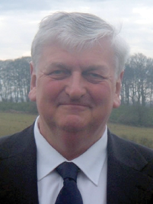

A new fascist party is being born in Britain. Called True Brits (TB), it is made up of current and former members of the British National Party (BNP) and it will seek to attract the hundreds of activists who have left the BNP in recent years.

**Andrew Brons**

But it will also bring together some of the more extreme elements of the British far right, including anti-Semites’ and holocaust deniers. Last month, Yorkshire and Humber MEP Andrew Brons resigned from the BNP claiming mistreatment from Nick Griffin and the party hierarchy. This was the green light the rebels had been waiting for. The fall-out between Brons and Griffin are organisational disputes rather than political differences and, if anything, the new party will be even more extreme than the BNP. It will remain embedded to racial nationalism and total opposition to a multiracial society. Only last year, in a radio interview, Brons described the English Democrats’ “courting of multiracialism” as the primary reason he opposed their party.

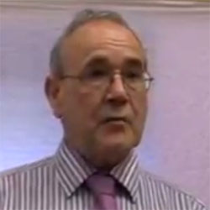  
**Peter Phillips**

The new party will include some of Britain’s most hard line racists, anti-Semites’ and Holocaust deniers. It will be BNP mark II but even more toxic. It will be TB in name and equally dangerous.

The new party will be led by Peter Phillips, a former BNP member who in 2006 stood for election as President of the Royal Institute of British Architects.

Andrew Brons will become its President. Newcastle-based Kevin Scott is acting as the Secretary of the Steering Group and Andrew Moffat and Ken Booth its deputy chairmen.

Around them will be former BNP organisers and activists, people drawn from small and hard line groups such as England First and the Democratic Nationalists and a number of former National Front activists who were prominent in the 1970s and 1980s.

The new party will include some of Britain’s most hard line racists, anti-Semites’ and Holocaust deniers. It will be BNP mark II but even more toxic. It will be TB in name and in nature. Its strength will initially be in the North East, Yorkshire, East Midlands and London, though it is likely to quickly attract other disillusioned BNP members from across the country.

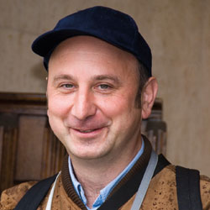  
**Bob Gertner**

Britain’s most hard line anti-Semites’ and Holocaust Deniers will be joining True Brits. These include Peter Rushton and Bob Gertner. It was Gertner, together with Phillips, who registered the party with the electoral commission.

Another person who has been involved in the discussions over the formation of the new party is Richard Edmonds, John Tyndall’s former deputy and now a leading figure in the National Front. Edmonds is a hardcore Nazi and Holocaust Denier, so any involvement from him will clearly demonstrate the true nature of Brons’ new party.

Brons’ group will be expected to contest some of the forthcoming parliamentary by-elections, including Middlesbrough and Croydon, both to be held on 29 November. However, the new party will really look towards next year’s county council elections to stamp their mark on the British far right.

The next few months will decide whether Brons’ new far right outfit replace Griffin’s BNP as the dominant force on the British far right or whether Griffin will weather the storm and remain in control. True Brits will have the activists and the enthusiasm but Griffin is a political street fighter and his party has the recognised brand name.

However, let us not think that there is anything moderate in this new party. It is simply BNP Mark II but even more toxic.

And whoever emerges dominant, HOPE not hate we will be there to oppose them at the ballot box and in the community.

## Key Backers: ****HOPE not hate profiles some of the people supporting the new party****

**Peter Phillips:** Phillips will become the leader of True Brits. A Surrey-based architect, Phillips attracted media attention in 2006 when his political affiliations became known during his candidacy for the presidency of the Royal Institute of British Architects (RIBA). In 2010 he was the BNP’s parliamentary candidate in Windsor, though soon after he was suspended from the party by Nick Griffin and became involved in the BNP Reform Group. In addition to his former BNP allegiances, Phillips was known within RIBA circles as having “particular unpleasant views on the abilities of women.”

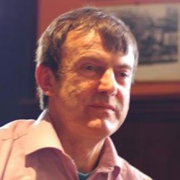

**Ken Booth:** Was the North East organiser in both the NF and later the BNP. He once described Auschwitz as being comparable to “Disney Land”, refusing to believe the “official figures” of those who died in the Holocaust and did not recognise the “authenticity” of the buildings at Auschwitz. Booth will become deputy chairman of True Brits.

**Andrew Moffat:** A former National Front member who was booted out of the Army in 1980. He was once David Irving’s political secretary and has remained close friends with former NF National Activities Organiser Martin Webster. He stood for UKIP in Beaconsfield in 2001, finishing in last place. He later joined the BNP, becoming the BNP’s economic spokesman and became Andrew Brons’ close political assistant, running his Brussels office. Moffat will become deputy chairman of True Brits.

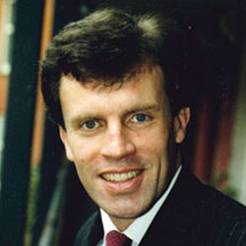

**Adrian Davies:** A former member of the Monday Club, Tory Action and London Swinton Circle, Davies has flirted with the extreme far-right in this country since the 1980s. In the 1990s he joined up with some BNP rebels to form the Freedom Party. A barrister by trade, Cambridge-educated Davies has registered a new political party in April 2011 in what would appear to be a premature move to align with Andrew Brons’s rebels. Davies was personal secretary to the Holocaust denier David Irving during the early ‘80s. In 1983 Davies was sharing a flat with Italian neo-Nazi Roberto Fiore, and Michael Walker editor of Scorpion magazine.

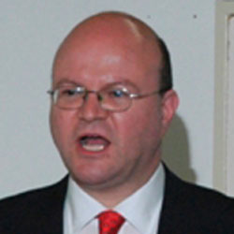

**Steve Brady:** Stephen John Brady is a veteran Nazi and former Vice-Chairman in the National Front. He has also been linked to the Loyalist paramilitary group, the Ulster Defence Association. He was also a founder member of the hardcore Nazi group the League of St George in the 1970s and became its international liaison officer. He once described the Italian fascist Ordine Nuovo as: “Basically neo-fascist urban guerrillas whose main activities are machine gunning Red marches, blowing up Red offices, car bombing of Reds, assassination of leading Reds and good clean fun of that sort.”Brady is arguably Brons’ closest political ally though he may prefer to play a more private role in True Brits, like he has done over the last few years with the BNP.

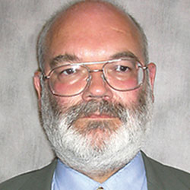

**James Lewthwaite:** Former Bradford BNP councillor and now leader of the Democratic Nationalists. He studied archaeology at Cambridge University and later went on to teach and research at Bradford, Lancaster and Sheffield Universities. Lewthwaite was exposed in 2004 as a publisher of books which glorified Hitler and Nazi Germany. Lewthwaite has been pushing hard for Brons to form a new party for some time.

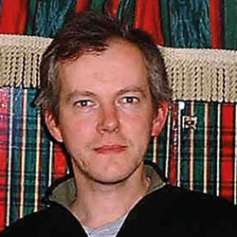

**Peter Rushton:** Rushton is one of Britain’s leading Holocaust deniers and has links to Nazi groups across Europe and anti-Semites’ in the Middle East. He was previously involved in the BNP but was expelled by Nick Griffin in 2002. He is currently deputy editor of Mark Cotterill’s magazine Heritage and Destiny and regularly speaks at National Front, British Movement and RVF events.

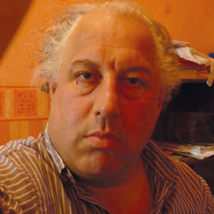

**Ivan Winters:** Former Bradford Conservative, Winters was once an active anti-fascist and even attended Trades Council meetings. He left the Conservative Party after being imprisoned for fraud. Winters is now involved with James Lewthwaite’s ‘Democratic Nationalists’ and has written extensively about the need to establish a new ‘nationalist’ party.

**Martin Wingfield:** A former chairman of the National Front, he was jailed for 90 days in 1984 for refusing to pay a fine after being convicted of distributing literature likely to stir up racial hatred. He joined the BNP in 2001 and became editor of the party’s newspaper. He is currently Andrew Brons’ communications officer. Wingfield is also closely linked to Steve Brady.

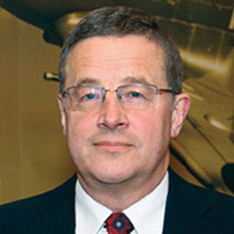



**Bob Gertner:** Former Croydon BNP organiser, Gertner is an active Holocaust denier and closely linked to Richard Edmonds. In 2000 attended the David Irving libel trial in the company of other BNP activists to offer him support and in his position as Croydon BNP organiser he regularly invited leading Holocaust deniers to speak. Gertner registered True Brits with the electoral commission along with Peter Phillips in November 2011.

**Richard Edmonds:** One of Britain’s most hard line national socialists and Holocaust deniers around, Edmonds joined the National Front in the early 1970s before moving over to the New National Front in 1980 and then becoming a founder member of the BNP in 1982. Always a close confident of John Tyndall, Edmonds is a unreconstructed Nazi. During the 1980s and 1990s he produced Holocaust News, a tabloid newspaper which denied the Holocaust. Today, he is still a vocal Holocaust denier and is closely linked to hard line Nazis across Europe. At the end of May 2011 Richard Edmonds was planning to challenge Griffin for the leadership of the BNP but stood down in favour of Andrew Brons.

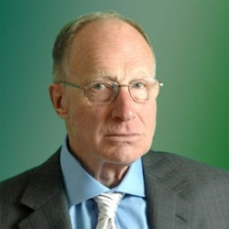

**Sending out the right message:**

**Why we must continue to fight against racism**

UCU alongside anti-racists organisations will continue to campaign against racism within our society. Our principles clearly state that we stand firm with the trade union movement to oppose all forms of prejudice, harassment and oppression.

Our rules set out this commitment to equality, justice and the right to organise in defence of our members. We believe that the doctrine of fascism represents the opposite of these values. Where we value diversity, fascist organisations seek to divide on the grounds of race, gender, religion, sexual orientation and disability. So, wherever and whenever you see or hear about a racist, homophobic, xenophobic, Islamophobic or anti-Semitic attacks challenge **it! Together we can effect change!**

**Materials and resources**

You can request copies of any of the resources shown here by sending an email to [eqadmin@ucu.org.uk](mailto:eqadmin@ucu.org.uk). Please remember to state the quantity required and your full postal details.

**If you are organising or supporting local events, please let us know. If you would like to be part of an email network group where we will specifically send you information and updates, please send an email to** [eqadmin@ucu.org.uk](mailto:eqadmin@ucu.org.uk) **with** ‘**join AF Network’** **in the subject header.**

[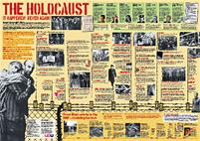](http://www.ucu.org.uk/media/photos/1/i/ucu_holocaust_timeline.jpg)

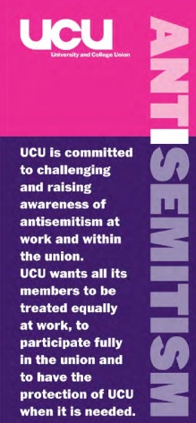 

**Get in touch!** We know that UCU members are doing fantastic work in the field of anti-racism and want you to continue.