No 59 May 2012 Congress Edition
Contents
1. TUC Biennial Safety Rep Survey
2. UCU Stress & Bullying Week
3. Three in four workers say managers lack leadership and skills
4. Fit for Work pilots unlikely to become a national service
5. EU Healthy Workplace campaign launched

6. UCU Congress 2012
7. Bullying or robust managerial style

8. H&S Training Courses 2012 -13
9. Congress Fringe Flyer

1) TUC Biennial Safety Rep Survey
The 2012 TUC health and safety representative’s survey is now available. It can be filled in on-line. The deadline for completed survey forms to be returned is 29th June 2012. The Labour Research Department is conducting the survey on behalf of the TUC
The on-line version is at http://www.tuc.org.uk/workplace/tuc-20893-f0.cfm
Please circulate it to as many health and safety representatives in your institution as possible, UCU and other unions, as the information we get from this survey proves to be invaluable to the TUC’s work. It is also about the only way that the trade unions know what the broad issues are, and how well we are organised to deal with health, safety or welfare conditions at work. It really is incumbent on us to use that information to identify our weaknesses and start to improve our local organisation.
I can send anyone who wants one a paper copy; just drop me an e-mail with a postal address. I will ensure there are copies available at UCU Congress in early June.
2) UCU Stress & Bullying Week
By the time you read this, the closing date for responses to the UCU Stress survey will have passed, but the results will be invaluable in helping us organise for the week. Dates are Monday 19th November to Friday 23rd November 2012. We should have some provisional survey results ready for the Congress fringe meeting.
We have a very striking poster for the week, thanks to colleagues in campaigns and publications, and we hope to start campaigning publicity earlier this year, and will be encouraging Branches and LA’s to organise some event or activity during the week.

3) Three in four workers say managers lack leadership and skills
Almost three-quarters of workers reported a lack of leadership and management skills in their organisations, and believe that too many managers have an inflated opinion of their own abilities, according to research released by the Chartered Institute of Personnel and Development's (CIPD) on May 3rd 2012.
Their latest Employee Outlook survey suggested that there is a significant "reality gap" between how good managers think they are in their roles and how effective they actually are.
The research also highlighted contrasts between how managers said they manage their people and the views of their employees. Sixty percent of managers said that they meet each person they manage at least twice a month to talk about their workload, meeting objectives and other work-related issues. However, only 24% of employees say they meet their managers with such frequency. While eighty per cent of managers said that they think their staff are satisfied or very satisfied with them as a manager, only 58% of employees agreed. More than 90% of managers said that they sometimes or always coach the people that they manage, only 40% of employees agreed. And, while 75% of managers said they always or sometimes discuss employees' development and career progression during one-to-one meetings, only 38% of employees said this was the case.
CIPD believes that too many employees are promoted into people management roles because they have good technical skills, then receive inadequate training and have little idea of how their behaviour impacts on others. From there, too many managers fall into a vicious circle of poor management; they don't spend enough time providing high-quality feedback to the people they manage, or coaching and developing them or tapping into their ideas and creativity, which means they then have to spend more time dealing with stressed staff, absence or conflict and the associated disciplinary and grievance issues.
The CIPD concluded that this "reality gap" is important because of the link between employees' satisfaction with their manager and their willingness to "go the extra mile" for their employer. Even a small increase in capability among UK managers could make a significant contribution to productivity and growth.
UCU thinks it’s about time employers started to talk to us about their criteria for appointing managers, and then training them. Perhaps we should propose all universities and colleges adopt the Oxford model – the fellows elect their own college head.

4) Fit for Work pilots unlikely to become a national service
As we reported in H&S News issue 57 in March, one of Dame Carol Black’s flagship recommendations in her 2008 report on health and work, the Fit for Work Service, is in real trouble. Now the author of the pilot scheme evaluation is reported to have said that it is unlikely to become a national service in the current economic climate, Occupational Health magazine says.
In what is likely to be a blow to the hopes of many occupational health practitioners, the idea of there ever being a "National Health at Work Service" could be fading fast.
The evaluation of the pilot schemes concluded that take-up had been disappointingly low and there had been difficulties in getting GPs to support the scheme, even though employers and employees who had used it said they had found it useful. There is evidence of some success, as one of the pilots, Leicestershire Fit for Work, reported its 1,000th referral from GPs and other health professionals during March this year. They also reported that over 73% of those who agreed an individual action plan successfully avoided long-term sickness absence. http://www.personneltoday.com/Home/
The TUC and trade unions are still concerned that there is still no commitment at governmental level towards establishing an effective occupational health and rehabilitation service for sick and injured workers that focuses on their needs, rather than reducing the claimant level for state sickness and other benefits. The TUC is also concerned that the HSE’s Employment Medical Advisory Service (EMAS) continues its apparently terminal decline. According to Prospect, the union for HSE Inspector grades, there are now only 2.2 medical doctors in post (as Medical Inspectors) and only 17 FTE occupational nurses (Occupational Health Inspectors) left. This rump probably just about satisfies the duty on the Secretary of State under Section 55 of the Health & Safety at Work Act to continue to maintain an employment medical advisory service.
5) EU Healthy Workplace campaign launched
“Every year more than 5,500 people lose their lives in the EU as a result of workplace accidents and more than 159,000 die from an occupational disease. Estimates vary, but accidents and ill-health cost the EU economy at least 490 billion Euros per year”.
At the end of April, the European Agency for Safety and Health at Work (EU-OSHA) launched a two-year Healthy Workplaces Campaign on “Working together for risk prevention”. The campaign turns the spotlight on the importance of management leadership and worker participation in improving workplace safety and health. The website introduction says that the Management Leadership in Occupational Safety and Health publication is “aimed at managers who wish to become leaders in safety and health”. Shouldn’t that be the aim of all managers and employers?

The EU Commissioner for Employment, Social Affairs and Inclusion, Mr László Andor spelled out the benefits of prioritising good health and safety when he launched the campaign, focussing yet again on the so-called ‘business case’. He said the campaign would result in: “...reduced costs and increased productivity; a happier and more productive workforce; lower rates of worker absence and turnover; fewer accidents; improved standing among suppliers and partners; greater awareness and control of workplace risks; and a better reputation for sustainability among investors, customers and communities.”

These justifications for improved health, safety and welfare have been promoted by the state, professional organisations, occupational health consultants and others for years and it seems we all understand them, with the exception of employers. One interesting challenge to the conventional wisdom that bullying as a managerial technique for gaining compliance is counter-productive has come from a couple of UCU colleagues at Manchester University, Dave Beale and Helge Hoel. They challenge the view that this is so, and suggest that some employers believe they can bully their way to success. I’m sure some of our reps can give examples.
One of the central planks of the EU-OSHA campaign is “Leadership”. (See Item 3 above) Go to http://www.healthy-workplaces.eu/en/ from where you can download the practical guides on Management Leadership and Worker Participation, when they are ready. Do employers in the UK really need guidance on worker participation after 34 years of the Safety Representatives and Safety Committees Regulations, predicated on employer reasonableness and cooperation – you bet they do!
In addition, the guide contains a self-assessment tool to help managers become effective leaders in occupational safety and health. We cannot evaluate that because it still isn’t available on the site.
6) UCU Congress 2012
UCU’s health and safety advisor will be staffing a stand at Congress as usual; this year our focus is on rats and mice. We’ll also be running a fringe meeting on the importance of Branches and LA’s appointing health and safety representatives to develop our organisation. That’s on Friday 8th June at 1.00 pm in room Exchange 11. See the flyer at the end of this news.
The Stress fringe meeting is at 1.00 pm on Saturday 9th June 2012, again in room Exchange 11, where some preliminary results from the current UCU stress survey will be presented and there will be opportunity to discuss where we go on stress issues, and the anti-stress and bullying week arrangements. We will also have copies of the new poster for the week available there.
I look forward to those of you who are Congress delegates this year coming over to say Hello – conference exhibition stands can be quite lonely and tedious places when delegates are in the sessions; and it’s always good to meet reps I’ve had contact with over the year. So hope to see some of you there.
7) Bullying or robust managerial style
You will remember that a few of you offered to run this little one-page questionnaire past some members to see if it was useful as a preliminary to a more detailed survey. We received some good feedback and a lot of suggestions; the most poignant feedback from one member was that if they had seen this earlier, they would have realised what was happening to them. If we had incorporated all the suggestions, it would have stretched the one-page beyond what we wanted to achieve. We did some small edits, and the result is reproduced on the following page. Please feel free to use it if you think it is useful. Meanwhile, we’ll keep it under review.
Robust management style or bullying questionnaire?
Most employers are reluctant to admit their managerial culture is based on, or includes, bullying. There is a body of research that purports to present evidence that bullying is counter-productive, and much assertion of this as fact from bodies like ACAS and the HSE, but still there are employers who deliberately adopt a confrontational and aggressive approach to managing staff. They must believe there is some advantage that outweighs the disadvantages.
Some employers accused of bullying often claim that it isn’t bullying, it is simply a robust managerial approach; and that in an academic environment, staff should be able to deal with that by argument and debate. This simple questionnaire should help you test if your employer is a bully or merely “robust”. The more you tick, the more it is likely you are being bullied, or that bullying occurs in your workplace. This should lead you to decide if you need to conduct a more thorough survey.

Element of managerial behaviour | Experienced | Witnessed
Constant criticism of a staff member’s professional competence
Spreading stories and innuendo about members of staff
Removing responsibilities from staff members
Always giving the same staff member trivial tasks to do
Shouting at staff in private
Shouting at staff in front of colleagues or students
Making threats
Persistently picking on staff in front of others or in private
Failing to include staff in meetings, briefings etc
Obstructing professional development opportunities
Blocking promotion
Ignoring a staff member’s views and opinions
Belittling individual members of staff
Constantly attacking a member of staff’s personal standing
Deliberately ignoring an individual’s contribution
Excluding individuals from work activities
Adopting different rules for different people
Excessive monitoring
Excessive and unnecessary criticism
Generating unrealistic expectations
Regularly making the same person the butt of jokes
Overloading and unrealistic work allocation
Setting a person up to fail by giving impossible tasks or deadlines
Failure to support staff having difficulty

Examples of other types of offensive behaviour

8) H&S Training Courses 2012 -13

H&S 2: Organising and bargaining for health & safety - London
3 days 19–21 June 2012
H&S 1: Induction - London
3 days 18–20 September 2012
H&S 1: Induction – Birmingham
3 days 16–18 October 2012
H&S 1: Induction - Manchester
3 days 14–16 November 2012
H&S 1: Induction - Taunton
3 days 26-28 November 2012
H&S 2: Organising and bargaining for health & safety - London
3 days 3–5 December 2012
H&S 1: Induction - London
3 days 8–10 January 2013
H&S 2: Organising and bargaining for health & safety - Manchester
3 days 6–8 March 2013
H&S 2: Organising and bargaining for health & safety - London
3 days 19–21 March 2013
H&S 2: Organising and bargaining for health & safety - Taunton
3 days 24-26 April 2013
H&S 2: Organising and bargaining for health & safety - Birmingham
3 days 4–6 June 2013

Details: http://www.ucu.org.uk/training
Contact Email: training@ucu.org.uk

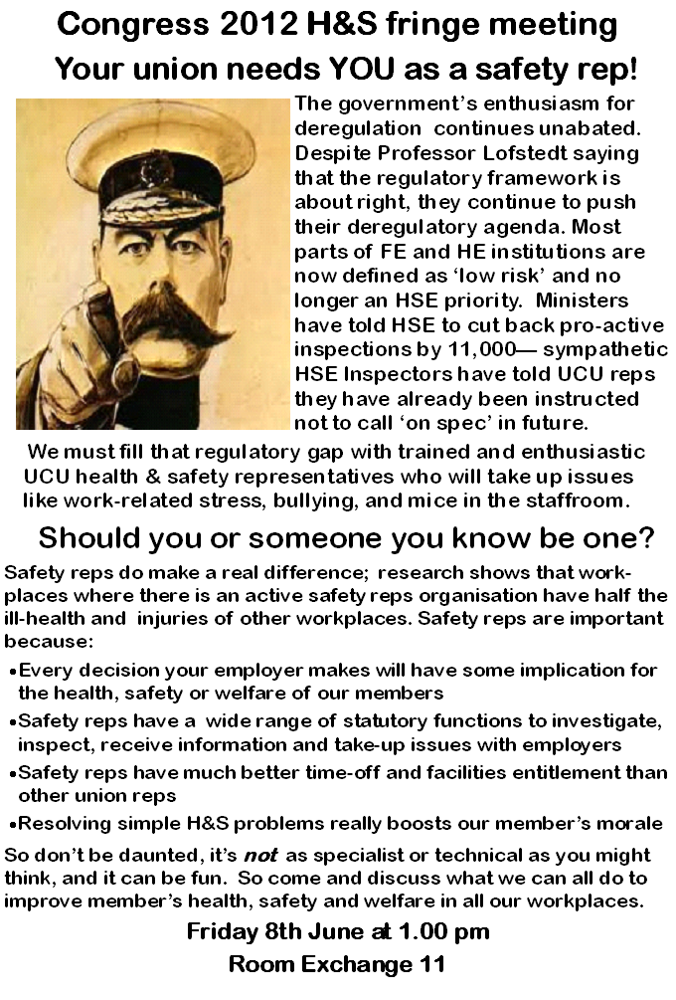

Contact UCU Health & Safety Advice
UCU Health & Safety Advice is provided by the Greater Manchester Hazards Centre, and is available for 3 days each week during extended term times. The contact person is John Bamford: (e) jbamford@ucu.org.uk
(t) 0161 636 7558

Visit the UCU Health and Safety web page:

http://www.ucu.org.uk/index.cfm?articleid=2132

