


A JOINT SURVEY BY IoE, NUT AND UCU ON THE CURRICULUM AND QUALIFICATIONS FOR 14-19 YEAR OLDS: TEACHER AND LECTURER PERSPECTIVES

FOREWORD

NUT and UCU members are among the main practitioners and deliverers of 14-19 education and training. We have all been through a period of change in this phase of education and training under the various Labour Governments. Since the Election it is clear that we are set for many more reforms, some of which at least will be fundamental. Moreover, the changes that are to take place in higher education have yet to be felt in the 14-19 phase and they will impact deeply on the decisions made by young people and their parents. We may well be seeing the end of a 14-19 phase of education and its replacement with distinct 14-16 and 16-19 phases. We may also see education become far more rigid and stratified, with young people forced to make vital decisions earlier and earlier. We are also seeing the Coalition Government attacking and diminishing the role of local authorities in education, and the expansion of autonomous academies, University Technical Colleges, 16-19 academies and free and studio schools.

In this context, it is vital for both unions that we know and understand the perceptions and attitudes of our members to the changes that have taken place, and are going to be implemented. This will allow us to put forward the kind of policies our members wish to see.

This joint Institute of Education, NUT and UCU survey is part of the wider work all three organisations are undertaking together, reflecting a commitment to and policies for an integrated and inclusive 14-19 system of education and training. The report is based on the findings from an electronic survey jointly undertaken and designed by all three organisations to try to ascertain members’ views about Key Stage 4 qualifications and programmes, post-16 qualifications and wider policy issues.

We hope that this joint endeavour will be a springboard for further collaboration between the IoE, the NUT and UCU, including more surveys and events to discuss various specific aspects and issues of 14-19 education and training.

Helen Hill  NUT Principal Officer, Secondary Education | Dan Taubman  UCU Senior National Education Official HE and Lifelong Learning

THE CURRICULUM AND QUALIFICATIONS FOR 14-19 YEAR OLDS: TEACHER AND LECTURER PERSPECTIVES

A Joint Institute of Education (IoE), National Union of Teachers (NUT) and University and Colleges’ Union (UCU) Survey

Ann Hodgson, Ken Spours and Caroline Wickenden
Institute of Education, University of London

THE IMPORTANCE OF THE PROFESSIONAL PERSPECTIVE

- Teachers and lecturers find themselves in an increasingly contradictory position. They have front-line responsibility for a wide range of students and have an enormous potential effect on their chances of success. At the same time, these education professionals have to cope with constant national change in terms of qualifications reform and institutions that are driven by a wide range of performance measures. While teachers and lecturers are ultimately the people who make national reforms work in practice, they often have little power in deciding the shape of the curriculum or which qualifications are used.

- The views that professionals have of curriculum and qualifications are thus framed not only by their everyday experiences with learners in classrooms, schools and colleges, but by the way in which their practice is influenced by national policy. This is particularly the case in 14-19 education and training because of the central role qualifications play in curriculum, assessment and pedagogy.

- This survey attempts to capture the perceptions of teachers and lecturers of the major aspects of New Labour’s 14-19 reforms between 2000 and 2010. This was a period of unprecedented innovation and all the indications are that the same pace of reform is occurring under the Coalition Government. It was also a period in which an overarching vision of 14-19 reform gradually faded. The idea of a unified and inclusive 14-19 system promised by Tomlinson was replaced by a piecemeal set of qualifications changes that pulled in different directions. This policy context encouraged a pragmatic professional response, which is evident in this survey.

POLICY AND ITS EFFECTS

- During the first decade of the 21st century, the previous New Labour government maintained a strong policy focus on 14-19 education and training, seeing reform in this area as necessary for improving attainment and increasing levels of post-16 participation. This policy approach was reflected in curriculum and qualifications reform, changes to institutional arrangements and local governance, capital spend on schools and colleges, the introduction of the Educational Maintenance Allowance (EMA) to support 16-19 year olds staying on in education and training and initiatives designed to widen participation in higher education.

- The focus on qualifications started in 2000 with the introduction of a two-stage A Level (AS/A2), the move from General National Vocational Qualifications (GNVQs) to Advanced Vocational Certificates of Education (AVCEs/Applied A Levels) and the promotion of Key Skills. Curriculum 2000, as these reforms became known, was swiftly followed by changes to the National Curriculum at Key Stage 4 and the introduction of the Increased Flexibility Programme to provide greater opportunity for applied/vocational study; the Tomlinson Review of 14-19 curriculum and qualifications and the subsequent 14-19 White Paper. Towards the end of the decade, GCSEs were also modularised with reductions in assessment by coursework. Throughout this period there was a major emphasis on improving performance in English and mathematics via a number of initiatives that included changes to GCSEs and the development of Functional Skills. The 14-19 White Paper published in 2005 announced the development of the new 14-19 Diplomas and supported the growth of 14-19 partnerships, but within what remained a competitive institutional climate. All these reforms were driven by central government via a range of policy levers – targets, inspection, performance measures and funding. By 2008, A Levels were being remodelled again through a reduction in the number of modules (from six to four), an increase in external assessment and the introduction of an A* grade to distinguish performance at the higher levels. Following the rejection of the Tomlinson Report with its recommendation for an inclusive and unified baccalaureate-style system to include all 14-19 learners, the New Labour Government had thus committed itself to the formation of a four route system – general (GCSEs, A Levels and the IB); Diplomas; Apprenticeships and the Foundation Learning Tier.

- In practice, 14-19 partnerships focused primarily on the delivery of Diplomas, not least because of the large amounts of funding available in this area. Schools gradually began to diversify the curriculum at Key Stage 4 and to improve access to learning in order to increase levels of post-16 participation and reduce levels of learner disengagement. The eventual widespread use of BTEC and other applied/vocational qualifications at Key Stage 4 was not simply driven by educational motives, but also by a desire to improve examination results at Key Stage 4 through the generous equivalences that were accorded to these qualifications. This practice was particularly prevalent among schools with high proportions of lower attaining learners who found themselves under pressure from Ofsted to improve their performance in the all important GCSE 5 A*-C measure.

- The outcomes from New Labour’s 14-19 reforms began to show later in the decade. By 2010 the combined effects of the EMA and more flexible approaches to the Key Stage 4 curriculum appeared to be encouraging more 16 year olds to stay on in full-time education, following a period in which little growth in participation had taken place. Strong increases in A Level and GCSE and equivalent attainment were evident. By 2009/10, 75 per cent of 16 year olds had gained 5 A*-C grades in GCSE or equivalent, although the attainment of five A*-C GCSE grades including English and Maths remained lower, at 54 per cent. There were also steady rises in higher education participation, both as a result of the qualifications reforms and a range of widening participation initiatives. However, these improvements were not without their problems in relation to progression from pre-16 to post-16 study and from mixed GCSE/BTEC programmes to A Level in particular. Moreover, throughout this period a steady stream of media commentary questioned the worth of young people’s examination results and expressed concerns about the reducing numbers of learners taking ‘harder subjects’, such as the sciences and modern languages.

- The strengths and weaknesses of New Labour’s record provided an important context for the incoming Coalition Government in 2010. Their policy to date on 14-19 education and training could be characterised as a mixture of ‘traditionalism’ and ‘markets’. They immediately stopped further funding for Diplomas and 14-19 developments more generally, swiftly introduced the English Baccalaureate performance measure, with its emphasis on the attainment of five ‘good’ GCSEs in maths, English, history/geography, a science and a language, and commissioned Professor Alison Wolf to undertake a quick review of 14-19 vocational education. Marketisation was taken to new levels - a new academies programme was introduced, focusing initially on high performing institutions, but with the intention for all schools to become academies in the longer run, and Free Schools, Studio Schools and UTCs are being encouraged.

- The picture we have painted here is one of a complex and rapidly changing policy landscape. What sense professionals made and are making of this terrain and its effects on their learners is reported and discussed below.

METHODOLOGY

- This report is based on the findings from an electronic survey that was jointly designed by representatives from the IoE, NUT and UCU. It had a set of common questions for both teachers and lecturers and also some more specific questions that related to one group of professionals only. The survey comprised a mix of closed, open and scaled questions, which allowed respondents to provide more detail about a certain aspect of policy if they so wished. A link to the survey was sent by email to 5000 NUT members, randomly selected from members working in secondary schools and sixth form colleges, and a random sample of 6000 UCU members working in FE. Owing to the nature of information held on the two unions’ membership records, and because members who received the email were invited to forward the link to colleagues where appropriate, it is difficult to identify precisely the number of professionals working specifically in the 14-19 stage who had sight of the survey. Just under 600 NUT and UCU members responded of whom the majority (73%) were teachers or lecturers. Only 15 per cent held the position of Head of Department/Faculty. Forty-one per cent had been teaching/managing learning for 15 or more years. Fifty-five per cent of respondents worked in either general FE or tertiary colleges (n=327) and 25 per cent in schools, including academies and independent schools (n=146). Fifteen per cent worked in sixth form colleges (n=91). Fifty-eight per cent of respondents were UCU members and 40 per cent NUT members. The majority (88%) of respondents teaching in sixth form colleges were NUT members.

- Not all respondents answered every question. This is partly explained by the design of the questionnaire: participants were only expected to respond to those areas in which they had experience or knowledge, but it may also have been influenced by the length and complexity of the survey. Unless otherwise stated, the figures reported below are based on the proportion of members who responded to each question, not the proportion of respondents to the survey in total. Variations in responses across workplaces are included, where relevant, but conclusions from these findings should be made with caution given the differences in the respondent sample sizes.

- Survey responses are grouped under four broad headings:

- Key Stage 4 Qualifications and Programmes
- Post-16 Qualifications and Programmes
- Learner Progression from Key Stage 4 and Post-16 Programmes
- Wider Policy Issues

MAIN FINDINGS

1. Key Stage 4 Qualifications and Programmes

The National Curriculum

- The majority of respondents agreed that the National Curriculum provides a good preparation for GCSE (77%) and all Level 1 (70%) and Level 2 study (67%). Findings show that opinion was more divided on whether the National Curriculum provides good preparation for A Level study and all Level 3 study with 53 per cent and 49 per cent in agreement respectively. Respondents were also divided on whether it provides a good foundation for all learners (55% agree) and breadth of learning (49% agree). The majority, however, did not agree that the National Curriculum encourages hard-work habits, with 14 per cent strongly disagreeing, or that it motivates young people (68% disagreed with 16% strongly disagreeing).

“The whole curriculum needs to be more flexible to reflect the world around kids today”

“It is important to offer a broad curriculum to suit all”

GCSEs

- Over half of those responding (n=139) stated that between 76 and 100 per cent of 14-16 year olds in their school take GCSE-only programmes. For 15 per cent of respondents, the proportion was less than a quarter of students.

- Just over half (53% of 138 respondents) reported the attainment range of those participating in GCSE-only programmes as being a mix of high, middle and low attaining learners. A further quarter stated that these programmes mainly comprised high attaining learners.

- Respondents were, in the main, split in their views of GCSEs, particularly on whether they provide good preparation for further study, both at A Level and all level 3 study, although responses were slightly more positive for A Levels.

 | Strongly agree | Agree | Disagree | Strongly disagree
GCSEs provide good preparation for A Level study (n=133) | 9% | 49% | 37% | 5%
GCSEs provide a good preparation for level 3 study (n=125) | 5% | 39% | 52% | 4%

“In an effort to improve results the exams have been made easier to pass over the years. This has led to a mismatch with A Level. The same drive has caused teachers to narrow their focus so that they are drilling students to pass exams and....the responsibility for learning is all now on the teacher...and so (students) are less well equipped to perform at A Level and beyond.”

- Whilst 53 per cent did not consider GCSEs to be a good foundation for all learners, a similar proportion of respondents (52%) believed that they encourage breadth of achievement.

“The GCSE syllabus has become very superficial, testing what can be easily quantified and not really looking to what REAL education is about.”

“I think the GCSE itself is a relatively useful and broad qualification, although increasingly the need to squash them into less and less time is devaluing them.”

- There was a fairly even divide in opinion on whether GCSEs encourage good work habits. On closer analysis, however, respondents were slightly more likely to have stronger negative views than strong positive views. Respondents were also divided on whether they believed GCSEs act as a motivator to young people.

 | Strongly agree | Agree | Disagree | Strongly disagree
GCSEs encourage good work habits (n=134) | 6% | 46% | 38% | 10%
GCSEs motivate young people  (n=135) | 57% | 43% | 44% | 6%

- Almost two thirds (64%) considered modular assessment in GCSEs to be a welcome development with 15 per cent strongly agreeing. However, over half (53%) did not believe that controlled assessment had been a positive development, with 22 per cent strongly disagreeing.

“The modular courses put a great deal of pressure on pupils as they are regularly sitting exams, but pupils always know where they are up to and what they must do to improve . Modular GCSEs work very well.”

“The modular approach encourages school leaders to think more about devices for achieving grades than about education. Schools are now grade factories.”

“I think the controlled assessments are horrendous.”

“New controlled assessment where no amendments are allowed will likely result in low achievement.”

- The majority of respondents (81%) agreed that GCSEs are valued by employers and higher education providers.

Vocational/applied awards at Key Stage 4

- A total of 119 respondents confirmed that their school offered qualifications/programmes other than GCSE. All but one respondent went on to answer the questions asked in this section.

- The most commonly offered qualification/programmes other than GCSEs were BTEC awards (83%), followed by ASDAN awards (42%) and Diplomas (41%).

- Almost half of the respondents (48.3%) stated that less than 25 per cent of 14-16 year olds took any type of vocational/applied award or programme. One fifth indicated that 26-50 per cent took such awards or programmes. The attainment range of those participating in a vocational/applied award was considered by 45 per cent to be a mix of high, middle and low attaining learners. A further 39 per cent said that the attainment range was limited to low attainers.

- The majority of respondents (77%) did not believe that vocational/applied awards provide a good preparation for A Level study or indeed for all Level 3 study (60%), and in the case of A Levels, 22 per cent strongly disagreed that such awards provide good preparation. Opinion was divided on whether vocational/applied awards provide a good foundation for all learners with 53 per cent agreeing and 47 per cent disagreeing.

“These are used extremely cynically to produce grades to affect a school’s position in the league tables. Pupils are withdrawn from a subject they enjoy even though they will not get a C grade and made to follow a course where a C grade, or higher, is guaranteed. Other pupils get the completely wrong idea about their ability and their suitability for A Level courses.”

“Vocational subjects are better suited to the BTEC structure although the idea they are equivalent of four GCSEs often is a joke.”

“They have a reputation as the easy option, however if done correctly, they are not and deserve equal status with GCSEs.”

- The majority (76%) did, however, believe that vocational/applied awards motivate young people, with 20 per cent strongly agreeing, and approximately two thirds thought that they encouraged breadth of achievement and hard work habits (62% and 67% respectively).

“(they) allow in-depth study in an area of future education, training and employment and develops different skills sets – more comparable with many work practices found today.”

“ASDAN courses such as CoPE provide an excellent environment to get youngsters to reengage with education.”

“BTECs at level 2 have motivated an awful lots of our students, they can see progression over a short timescale and the regular reporting back that is carried out by teaching staff is invaluable.”

- However, only 38 per cent thought they were valued by employers and higher education providers.

- Further comments offered by respondents reflect the range of opinions on vocational/applied awards at Key Stage 4:

“We have to pass students who I don’t believe should pass. They are allowed as many times as they want to write the coursework.”

“BTECs have wrecked our system, vocational qualifications have a place in colleges, but not in schools....too many learners are pushed into BTECs because they provide schools with more points, higher VA and impressive league tables. Very few cannot do GCSEs....I welcome an emphasis on a challenging and academic education system.”

“The government needs to realise that GCSEs and A Levels are not the only route in education. Too many children feel like ‘failures’ because they are forced down a route which is not suited to their ability or needs.......these children need the basics and then a vocational skill in something they are good at and interested in. Why should these children have to fail at GCSE first before going off to college as a ‘drop out’ to learn how to be a hairdresser/electrician etc.?”

“Keep the BTEC and ensure that vocational qualifications do take an important part in the active economic working life of the country.”

Foundation Learning programmes

- Since only 24 members confirmed that 14-16 year old students in their school were on a Foundation Learning programme, the response rate was considered too low to provide useful findings. In itself the low profile of these programme is interesting.

Functional Skills programmes

- Only 51 respondents confirmed that students in their school were enrolled on a Functional Skills programme (60% of whom said that this represented less than 25% of students), and findings revealed broadly negative views of the programmes. The majority did not consider them to provide a good foundation for level 3 study (75%), support breadth of achievement (63%), encourage hard work habits (61%) or motivate young people (69%). Furthermore, 79 per cent did not consider them to be valued by employers or further and higher education providers. There was slightly more support for the view that they provide a good foundation for level 2 study (51% agreed).

“These qualifications are a joke. Cannot believe children are wasting their time and energy failing at these qualifications.”

“I am more concerned to see Functional Skills embedded in existing programmes for English and Numeracy.”

“The (exam) papers seem to be aimed at older people with much more experience of life.”

College-based provision for 14-16 year olds

- A total of 294 respondents confirmed that their college taught students aged 14-16, 20 of whom were staff teaching in sixth form colleges.

- The majority of respondents (69%) stated that their institution was involved in a local partnership to support provision for 14-16 year olds based in a college, 22 per cent were respondents from schools. Just over 60 per cent of respondents, did not know how many institutions were involved in this partnership, however. Of those that did know, the most common number (across schools, FE/Tertiary colleges and sixth form colleges) was three to five institutions.

- The most common curriculum areas involved, as listed by respondents, are shown overleaf:

Curriculum areas involved in college-based provision for 14-16 year olds: most common areas | No. respondents
Construction | 65
Hair and Beauty | 58
Engineering | 39
Vehicle/Motor maintenance | 30
Health and Social Care | 27

- When asked to describe their perception of how 14-16 students are selected for study at college, some chose to explain the process itself, e.g. initial assessment, interview or school recommendation, whilst others commented, particularly those teaching in FE/Tertiary colleges, that they perceived that there was very little by way of process:

“No selection – take anybody.” (College)

“If they can stand up they are in.” (College)

“Anyone with a pulse.” (College)

- Others commented on the types of students that were selected. Of those who provided comments 102 respondents said that the students who were chosen were low achievers/disaffected/excluded. Twelve stated that students were chosen because of their interest in a subject. Some discussed this in a positive light while others were more critical. Furthermore, comments suggested that whilst some respondents from schools saw the selection as giving students a chance or a new experience, many in FE/Tertiary colleges perceived it as a way for schools to ‘offload’ difficult students.

“Because they don’t ‘fit’ into school very well and need a new experience more suited to their needs.” (School)

“low achieving students are encouraged to take vocational courses where they would not achieve well with traditional GCSEs.” (School)

“the majority are the ‘hard to teach’ learner that schools are quite happy to send to FE college - it ticks another box.” (College)

“rather than exclude them from school – thereby adversely affecting the school’s figures – they are transferred to a construction course which is nothing more than a convenient dumping ground.” (College)

“They use us as a babysitting service for their less interested students.” (College)

- Sixty-one per cent of those responding (n=349) stated that the 14-16 students enrolled in college attended mainly on a part time basis, a further 26 per cent, however, didn’t know.

- Those responding (n=336) indicated that the most common qualifications offered to 14-16 year old students attending college-based programmes were BTEC awards (42%), Diplomas (32%) and NVQs (25%). Forty per cent, however, did not know.

- Just over a fifth stated that the 14-16 year olds attending college-based programmes were mainly middle or low attainers, with a further fifth stating they received only low attainers. Almost a third (31%) did not know the attainment level of their students, with those in FE/tertiary colleges more likely to say they did not know, compared to those respondents working in schools or sixth form colleges.

- The majority of those responding were largely positive in their views of such provision and felt that it motivates young people (72%), raises attainment (61%) and promotes progression within college (77%). Although most showed support for this provision, it is interesting to note that those in schools were, on the whole, more likely to strongly agree than colleges on the subjects of motivation and attainment.

College provision for 14-16 year olds motivates young people | Strongly agree | Agree | Disagree | Strongly disagree
School respondents (n=53) | 21% | 64% | 13% | 2%
FE/Tertiary college respondents  (n=178) | 9% | 58% | 28% | 5%
Sixth form college respondents  (n=15) | 13% | 60% | 20% | 7%

College provision for 14-16 year olds raises attainment | Strongly agree | Agree | Disagree | Strongly disagree
School respondents (n=54) | 15% | 48% | 33% | 4%
FE/Tertiary college respondents  (n=173) | 8% | 52% | 34% | 6%
Sixth form college respondents  (n=14) | 7% | 50% | 43% | 0%

- The majority (74%) also didn’t believe that such provision had more negative than positive effects. Again, schools were more likely to strongly disagree on this than FE/Tertiary colleges (21% compared to 14%).

“We have excellent partnerships. The students look forward to their college day and are re-motivated when they return to school. NEET rate is consequently lower at the end of Year 11.” (School)

“It provides them with a valuable opportunity to consider whether they are really suitable and sufficiently interested in a particular career to continue with it at college.....it also means they are familiar with the college environment and don’t have such a period of adjustment as other learner who don’t have that experience.” (College)

“Although they can often be challenging learners, I believe that we make a big difference to the students and we often see a big improvement in attitude, behaviour and achievement when the students are with us.” (College)

- Despite the mainly positive views of college-based provision, opinion across respondents was more divided on who should take responsibility for provision for 14-16 year olds. Just over half felt it should be schools and 48 per cent thought it should be colleges. When looking at the institutions that respondents teach in, findings revealed that those who agreed that it should be down to schools were, perhaps unsurprisingly, more likely to be respondents from colleges (including sixth form colleges). Those in schools were most likely to disagree.

Provision for 14-16 year olds should be the responsibility of schools rather than colleges | Strongly agree | Agree | Disagree | Strongly disagree
School respondents (n=54) | 13% | 28% | 43% | 16%
FE/Tertiary college respondents  (n=188) | 24% | 30% | 40% | 6%
Sixth form college respondents  (n=16) | 38% | 31% | 25% | 6%

“The presence of 14-16 year olds at my sixth form college puts added pressure on scarce resources and classrooms. While the younger students seem to benefit, my 16-19 year olds are unable to access computer rooms on the day the visitors are in.” (sixth form college)

“FE lecturers are not paid as well and colleges are not funded as well to teach these sorts of students. Many lecturers are not trained to deal with younger pupils and their associated problems/needs.” (College)

“Learners would be better off in school improving basic maths and English, then coming to FE at 16 when they are literate and numerate.” (College)

“We have had some success with 14-16 students but we do not really have suitable facilities for them and despite our expertise schools will be retaining these students in future because of funding cuts.” (College)

2. Post-16 Qualifications and Programmes

A Level programmes

- Sixteen-nineteen year olds formed part of the student population in the institutions of the vast majority who responded (92% of 515 respondents). Thirty-seven per cent confirmed that their institution is involved in a partnership between schools and colleges for 16-19 year olds, although a further 35 per cent did not know (largely those from FE/Tertiary colleges were most likely not to know).

- The majority (82%) of those responding (n=470) confirmed that their institution offered A Levels. A quarter of respondents (n=385) stated that between 76-100 per cent of 16-19 year old students took A Level only programmes, although a further 38 per cent didn’t know (again, these respondents were most likely to be working in FE/Tertiary colleges).

- The previous attainment profile of the majority of those taking A Levels in respondents’ institution varied across type of respondent. Those teaching in FE/Tertiary colleges were most likely not to be aware of the profile.

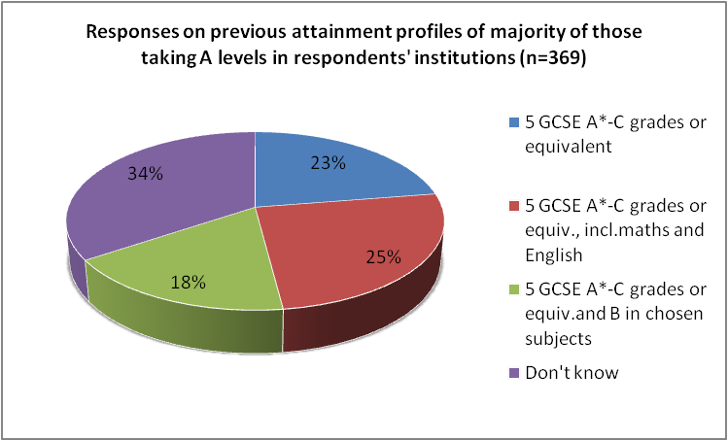

- The large majority (90%) thought that A Levels provide a good preparation for specialist study in higher education and encourage hard-work habits and 93 per cent thought they are valued by employers and HE providers. Three-quarters also agreed that A Levels motivate young people and a slightly smaller majority (62%) felt they encourage breadth of achievement.

“A Levels are not qualifications to be taken by anyone – they have a specific role and function i.e. access to HE and are incredibly taxing for today’s young people” (sixth form college)

“It broadens the mind and allows for depth of analysis” (sixth form college)

- Responses were mixed, however, on questions of design and assessment. The majority (70%) saw modular assessment as an important part of A Levels. Fifty-nine per cent agreed that they should be predominantly modular in their design and assessment and 51 per cent believed they should be predominantly linear.

“Exams at the end of AS and A2 is sufficient – no need for more modules and constant cycle of exams every January and June.” (College)

- Eighty-one per cent supported the option of dropping a subject at AS level – 21 per cent strongly agreed with this.

- A minority (30%) thought that A Levels have become more difficult since 2008 and only 40 per cent saw them as more rigorous since the introduction of more stretching questions.

“The state has watered A Levels down to point where you gain a straight pass with more of the paper failed.” (College)

“They are too soft and the constant changes just lead to more dumbing down.” (College)

“They ARE harder and the annual demeaning of students’ achievement and teachers’ hard work gets harder to ignore and shrug off when those who should know better jump on the bandwagon for publicity.” (School)

- Opinion was divided on whether fewer young people in the respondent’s school/college would enter A Levels in the future (51% agreed, 49% disagreed). On closer analysis, those in FE/tertiary colleges were most likely to agree with this (61% of FE/tertiary college respondents) whilst those in schools were most likely to disagree (66% of school respondents).

- Differences in opinion were also evident on the introduction of the A* grade with 53 per cent agreeing it had been a positive reform for A Levels and 47 per cent disagreeing. Those in sixth form colleges and schools were more likely to strongly agree that they were a positive reform than those in FE/tertiary colleges.

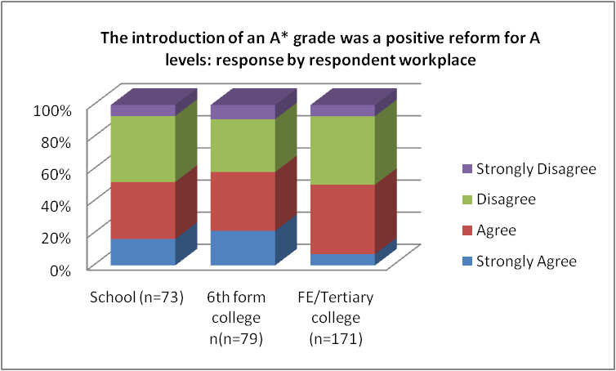

“In English, A*does neither stretch nor challenge, especially compared to previous extension exams. Students from 1999 would laugh at how little students have to do today and how often they can re-sit modules.” (College)

“A* grades will tend to favour those from more privileged backgrounds.” (Other institution)

- Some commented on concerns in the gap between GCSE and A Levels:

“GCSEs are becoming less rigorous and this means more time is spent ‘filling in gaps’ at AS level.” (Sixth form college)

“Students are thrown into A Level study from lower school and in my limited experience the transition from GCSE study to A Level is not explained and supported enough.” (College)

“A Levels are too easy but then the students who are taking them have gained few real skills and little genuine knowledge at GCSE.” (Sixth form college)

- The most commonly cited other general qualifications available to 16-19 year olds in the respondents’ institutions were Duke of Edinburgh Award (59%) and Extended Project Qualification (53%).

- Almost half of respondents (48% of 447) reported that less than 25 per cent of 16-19 students in their institution are involved in GCSE re-sits. A further 39 per cent did not know (mainly respondents in FE/Tertiary colleges). The majority (90% of 445) stated that most 16-19 students in their institution are on full-time programmes.

Vocational/applied qualifications for 16-19 year olds

- The majority of those who responded (85% of 449) stated that their institution offers vocational/ applied qualifications to students aged 16-19. This included 50 respondents from schools and 75 from sixth form colleges. The most common qualifications offered were BTECs (86%), Diplomas (51%) and NVQs (48%). As may be expected, the range of qualifications in FE/Tertiary colleges was wider than in schools and sixth form colleges, where BTECs were by far the most popular awards (identified by 81% of school respondents and 93% of sixth form college respondents).

- Thirty-six per cent stated that less than 25 per cent of 16-19 year olds take a mixed programme that includes one or more general qualifications and one or more vocational/applied awards. Thirty-eight per cent of all those responding, however, did not know. Those in schools and sixth form colleges were most likely to confirm that the proportion was less than a quarter of 16-19 year olds (57% of school respondents and 49% of sixth form college respondents). Those in FE/Tertiary colleges were most likely to state they did not know (49% of FE/Tertiary college respondents).

- A quarter of respondents thought that the volume of post-16 mixed provision was growing slowly but, a third of respondents did not know. The split in opinions on rate of growth was also evident across schools, sixth form colleges and FE/Tertiary colleges. Those in schools and sixth form colleges were most likely to say that growth was slow, whilst those in FE/Tertiary colleges were most likely to say they did not know.

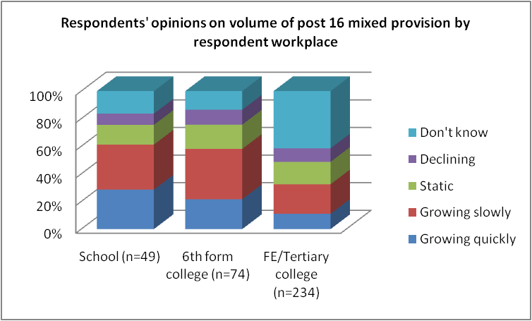

Diplomas for 16-19 year olds

- A total of 151 (41% of 369 respondents) stated that students at their institution study Diploma programmes either within their own institution or at another through a partnership. This was predominantly made up of those from FE/Tertiary colleges, with only 12 respondents from schools and 25 from sixth form colleges confirming such programmes are available.

- When asked about the proportion of 16-19 students taking Diplomas at Levels 1, 2 and 3, almost half of respondents did not know (41%, 43% and 43% respectively). For all levels, where known, most respondents stated that the proportion was 25 per cent or less.

- Over 90 per cent of the 149 responding confirmed that their institution delivers Diplomas to 16-19 year olds, and this was mainly those teaching in FE/Tertiary colleges (10 from schools and 25 from sixth form colleges). Many of those responding did not know which Diploma lines were offered by their institution at Levels 1, 2 and 3 (40%, 36% and 35% respectively). Of those that did know, the most common subject areas are shown below:

Level | Most commonly cited Diploma lines offered by institution  (% of respondents)
Level 1  (n=124) | Hair and Beauty Studies (27.4%)  Construction and the Built Environment (27.4%)
Level 2  (n=124) | Construction and the Built Environment (32.3%)  Business, Admin and Finance (31.5%)  Hair and Beauty Studies (31.5%)
Level 3  (n=128) | Creative and Media (32.8%)  Business, Admin and Finance (30.5%)

- Almost half of those responding (47% of 138) did not know if their institution enabled students who are primarily studying at their institution to take up Diplomas at other institutions within a local partnership. Only 18 per cent said this was a possibility.

- When asked which Diploma lines are offered to students within local partnerships at Levels 1, 2 and 3 only 22 respondents in total responded, most of whom said they did not know. Similarly only 24 respondents in total answered questions about their views on Diploma programmes.

Vocational qualifications and Diplomas for 16-19 year olds

- Approximately two-thirds of those responding thought that Vocational Qualifications and Diplomas provide a good preparation for specialist study in higher education (64%), encourage hard-work habits (63%) and breadth of achievement (69%). The majority (73%) also believed that they motivate young people.

“Vocational qualifications allow students to gain real life experience whilst studying.” (College)

“The BTEC diplomas in IT we deliver cover more material to a greater depth than the A Level in computing can.” (College)

“BTECs offer a good alternative – the ones I know about have a good range of interesting modules and provide a real alternative for students who cannot cope with exams and are interested in a specific vocational area.” (College)

- Respondents were more divided in their opinions on whether vocational qualifications and Diplomas are valued by employers and HE providers, with 59 per cent agreeing and 41 per cent disagreeing. This split in opinion could be partly explained by differences found when comparing across institutions: those working in FE/Tertiary colleges were most likely to agree that they are of value (62% of FE/Tertiary college respondents), whilst school respondents were most likely to disagree (58% of school respondents).

“Qualifications are not valued by employers, they don’t know what they are. But universities do value them. If they were externally examined then employers would value them, but EdExcel will not pay for this. “(College)

- Almost all who responded (92% of 290 respondents) considered continuous assessment to be an important part of Vocational Qualifications and Diplomas, with 36 per cent strongly agreeing. The majority (71%) did not, however, think they had become more difficult since 2008 and 67 per cent did not envisage fewer young people in their school/college entering Vocational Qualifications and Diplomas in the future. Whilst this was the case across schools and colleges, those in schools were slightly more likely than those in colleges to expect fewer entering such qualifications in the future.

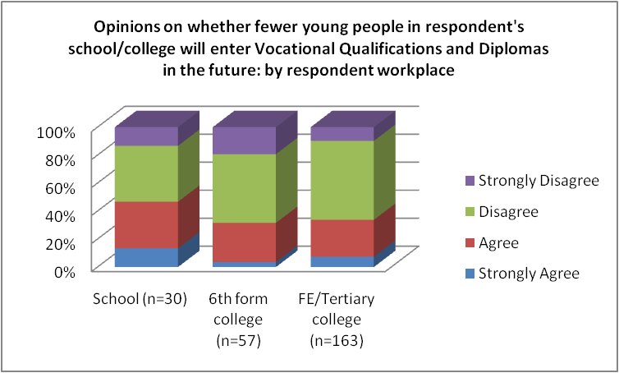

“Vocational qualifications are a poor substitute for A Levels. They are too easy and do not prepare student for the world of work.” (College)

“Far too often run as an easy option that students just can’t fail, therefore making the results look far better than they actually are.” (College)

“Our college is keen to do more of these qualifications because as long as the teachers work hard enough the students get great value added. We also get more ‘bums on seats’ even though many students are very unwilling learners.” (Sixth form college)

“It remains to be seen how many learners now progress from school to an apprenticeship given the government drive to increase apprenticeships. The funding constraints in FE, meaning more training providers can offer apprenticeships, put the future of FE provision at risk.” (College)

Foundation Learning programmes for 16-19 year olds

- Just under half of those responding (49% of 352 respondents) confirmed that there were 16-19 year old students at their institution on a Foundation Learning programme, the majority being those from FE/Tertiary colleges.

- Over half of those responding (52% of 237 respondents) did not know how many 16-19 year olds in their institution were on a Foundation Learning programme. For 37 per cent, the proportion was considered to be less than a quarter. Similarly, 58 per cent of respondents (n=215) did not know the previous attainment profile of the majority of 16-19 year olds taking Foundation Learning. Just over 30 per cent considered it to be fewer than 5 GCSE grades A*-G or equivalent.

- Whilst 68 per cent thought that Foundation Learning programmes encourage breadth of achievement and motivate young people, only a minority (39%) thought that they are valued by employers and FE providers. Respondents in schools were much less likely than those in colleges to consider the programmes as motivational, with just as many strongly disagreeing as agreeing (36% of school respondents). School respondents were also far more likely than those in FE/Tertiary colleges to strongly disagree that Foundation Learning programmes are valued by employers and further education providers, whilst those in sixth form colleges were evenly divided on their views.

Foundation Learning at 16-19 is valued by employers and FE provider | Strongly agree | Agree | Disagree | Strongly disagree
School respondents (n=11) | 9% | 27% | 18% | 46%
FE/Tertiary college respondents  (n=87) | 6% | 32% | 49% | 13%
Sixth form college respondents  (n=12) | 0% | 50% | 50% | 0%

“The new FLT framework is really helpful to those learners who did not achieve sufficient GCSE equivalent qualifications at school and gives them a second chance.” (College)

“Allows students to continue in education when they have few qualifications that would stop them enrolling on higher level courses.” (College)

“The implementation of the Foundation Learning has not gone down well with learners, or staff.” (College)

- Most (92%) considered continuous assessment to be an important part of Foundation Learning, with 23 per cent strongly agreeing. This was particularly so for those respondents in colleges, with 23 per cent of sixth form college respondents and 23 per cent of FE/Tertiary college respondents strongly agreeing (compared to only 8% of school respondents).

- The majority (65%) did not envisage fewer young people in their school/college entering Foundation Learning in the future. This view was mainly held by those from colleges. The few respondents from schools (n=11) were more likely to envisage a drop in intake (64% of school respondents) and those in sixth form colleges (n=12) were divided.

Functional Skills programmes for 16-19 year olds

- The majority responding (70% of 235) stated that there were 16-19 year old students in their institution on a Functional Skills programme, as would be expected, most were FE/Tertiary college respondents (with four respondents from schools and 15 from sixth form colleges).

- Nearly 40 per cent did not know the proportion of 16-19 year olds on the programme but 26 per cent reported it to be between 76-100 per cent and a further 17 per cent said less than 25 per cent. Those in colleges were most likely to report it to be 76-100 per cent of 16-19 year olds.

- Two thirds of respondents (n=223) thought that Functional Skills provide a good foundation for Level 2 study, although half of the respondents from schools (n=16) did not agree. Opinion was more divided on whether it provides a good foundation for Level 3 study (52% agreeing), with schools and sixth form respondents most likely to disagree (71% of 17 school respondents and 58% of 36 sixth form respondents).

- Sixty per cent of respondents considered the programme to be a good foundation for all learners, but again, this was largely the view held by those in FE/Tertiary colleges. Fifty-nine per cent of school respondents and 58 per cent of sixth form respondents disagreed.

- Opinion was divided on whether Functional Skills support breadth of achievement with 52 per cent agreeing and 48 per cent disagreeing. This was evident across all respondent workplaces, although those in sixth form colleges were slightly more likely to disagree (63% of sixth form respondents).

- The majority of those who responded did not believe that Functional Skills encourage hard-work habits (60% of 220 respondents), are of value to employers, FE and HE education providers (65% of 218 respondents) or motivate young people (74% of 221 respondents).

“I think it is a useful qualification and I feel frustrated that employers/HE providers seem to be unaware of it and do not value it.” (College)

“I can see the benefit of Functional Skills, however the students still don’t, and employers as yet don’t, understand what they are. They say that it is devaluing what they have already achieved, explaining that it is functional and applicable to the workplace doesn’t seem to have the desired effect” (College)

“Motivation does not come from the programme you are on, but comes from the individual and I think insisting on all full time learners taking Functional Skills so that they have not ‘chosen’ it means that young people don’t often value it either” (College)

“Calling maths, English or any other subject a functional skill does not change its place in the world! These are basic requirements in today’s world and should be taught before 14 years old! Not alongside vocational training at 16-19. (College)

- Further comments provided also suggested that some respondents perceive Functional Skills programmes as a means of increasing funding received.

“They have little value to industry or students and have become a bolt on for colleges to claim more funding.” (College)

“Only done to allow the college to make money. Very few learners want to do it, many actively resist doing it and cause problems.” (College)

Summary of comparison of opinions across programmes of study/awards/qualifications

- This comparison is based on the responses to questions about the National Curriculum, GCSEs, vocational/applied awards (in schools) and college-based provision for 14-16 year olds, together with vocational qualifications and diplomas, A Levels, Functional Skills and Foundation Learning programmes for 16-19 year olds.

- Whilst opinion was divided on whether the National Curriculum and GCSEs provide good preparation for A Levels, with respondents being slightly more in agreement, than disagreement, most responding did not think this was the case for vocational/applied qualifications in schools.

- Most respondents thought that the programmes/awards for 14-16 year olds provide a good breadth of achievement but they did not expect this to be the case for the English Baccalaureate (see 4. below).

- Respondents were most likely to view each of the programmes/awards as encouraging good work habits and acting as a motivator to young people, with the exception of the National Curriculum, the English Baccalaureate and Functional Skills at 16-19. Opinion was divided on GCSEs.

- All programmes/awards for both 14-16 year olds and 16-19 year olds were considered to be valued by employers and HE providers, with the exception of vocational/applied awards in schools and Functional Skills and Foundation Learning programmes for 16-19 year olds. Respondents were most likely to agree that employers and HE providers valued the ‘academic’ awards of GCSEs and A Levels.

- Most did not envisage fewer 16-19 year olds entering vocational qualifications/Diplomas and Foundation Learning in the future. However this was not the case for A Levels where opinion was divided.

- Both A Levels and post-16 vocational qualifications/Diplomas were considered good preparation for specialist study at HE level, but respondents were more likely to agree this was true for A Levels than for vocational awards.

- Support for continuous/modular assessment was apparent across relevant awards and this was particularly so for post-16 vocational qualifications/Diplomas and Foundation Learning.

3. Learner Progression from Key Stage 4 and Post-16 Programmes

Progression from Key Stage 4

- Of 131 respondents, just over half (52%) stated that the majority of 14-16 students in their school progress to further study in school, whilst 38 per cent said the majority progress to further study in a college. Less than 1 per cent said that students progress to employment.

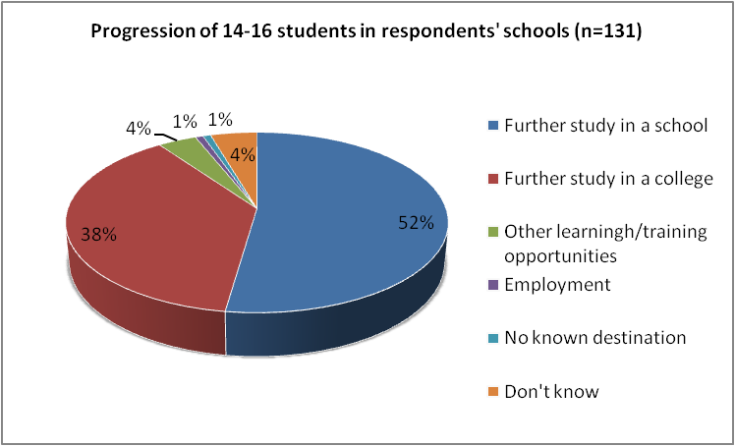

- Of 130 respondents, 71 per cent said that students enrolled at their school attended a sixth form, tertiary or FE college as part of their learning programme.

Post-16 student progression

- Almost half of respondents (45% of 408 respondents) stated that most of their post-16 students progress to university. Fifteen per cent said they went on to further study in a college and only 12 per cent indicated they went into employment. Seventeen per cent did not know.

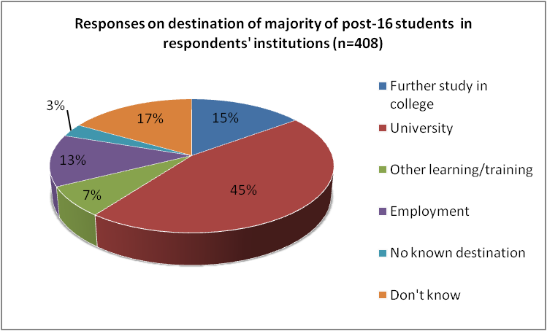

- Respondents in schools and sixth form colleges were most likely to say that students progressed to university (75% of 81 school respondents and 86% of 83 sixth form college respondents). Responses from those working in FE/Tertiary colleges were more varied, with almost a quarter saying they did not know where their students went on leaving the college (24% of 231 respondents).

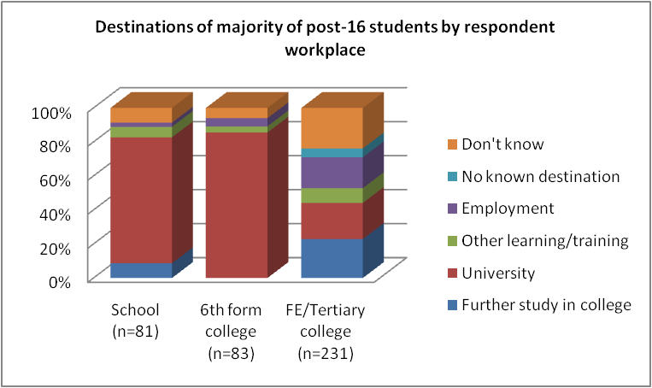

4. Wider Policy Issues

The English Baccalaureate and the Schools’ White Paper

- A total of 124 respondents stated that they had heard of the English Baccalaureate introduced as a retrospective performance measure by the Coalition Government in spring 2011.

- There was an almost even divide in opinions amongst those who responded on whether the English Baccalaureate will provide good preparation for A Level study and encourage hard-work habits, however on both questions, respondents were more likely to say they strongly disagreed than strongly agreed.

 | Strongly agree | Agree | Disagree | Strongly disagree
The English Bac will provide good preparation for A Level study (n=126) | 8% | 43% | 35% | 14%
The English Bac will encourage hard-work habits (n=123) | 9% | 32% | 45% | 15%

- The majority (62%) did not believe that the English Baccalaureate would encourage breadth of achievement (24% strongly disagreed) or that it would motivate young people (75% disagreed, with 19% strongly disagreeing). The vast majority (96%) also did not think that it would meet the needs of all learners, with almost two thirds (62%) strongly disagreeing.

“(The English Bac) will be used as a measuring stick and will make some students feel like second class citizens.”

“We asked the middle leaders in our school who would have passed the BAC based on our own GCSEs. Two members of staff out of 15 would have passed. Would we have got into university if the BAC was in place?”

“I work in SEN in mainstream school and the introduction of the English Bac has meant students at KS4 are on a different track from their peers as they have no chance of gaining English Bac – they are ‘written off’ and on vocational courses. Doesn’t value students who may be dyslexic or have skills in other areas of the curriculum”

“By introducing the Bac, many pupils and teachers of the arts are de-motivated by the government’s hierarchical view of different subjects.”

“One size doesn’t fit all.”

“A return to a narrow restrictive curriculum that will exclude students who learn at a different pace and in different styles. It will create an exclusive curriculum not an inclusive one – why not be honest and return to Grammar Schools and Secondary Moderns?”

“Grammar school values at the expense of the broad and balanced curriculum I have been promoting for 31 years”

- Most of those who responded (60% of 123 respondents) thought that the English Baccalaureate would be valued by employers and higher education providers. Over half thought it would stimulate changes to the Key Stage 4 curriculum, but respondents were almost equally as likely to strongly agree as they were to strongly disagree (11% and 10% of respondents respectively) with this statement.

- Almost two thirds (65%) thought that the English Bac would be difficult to deliver, with 17 per cent strongly agreeing, and a large majority (85%) believed that it would create more divisions between schools/learning institutions, with 39 per cent strongly agreeing. The majority (88%) thought that it would devalue vocational/applied education at Key Stage 4, with half of those responding strongly agreeing.

- A total of 63 per cent agreed that the inclusion of a language in the English Baccalaureate was a good idea, but there was little difference in the proportions expressing strong opinions either way (18% strongly agreed, 16% strongly disagreed).

“Languages are essential and it’s time people started to take them more seriously.”

“Schools where languages are already well established... will be well prepared. I imagine there will be many worried Heads out there re KS4 languages who have decimated MFL and Humanities in recent years!”

- The proportions of 14-16 year olds currently taking a language at GCSE (either a modern foreign, community or ancient language) varied across respondents’ schools as shown below:

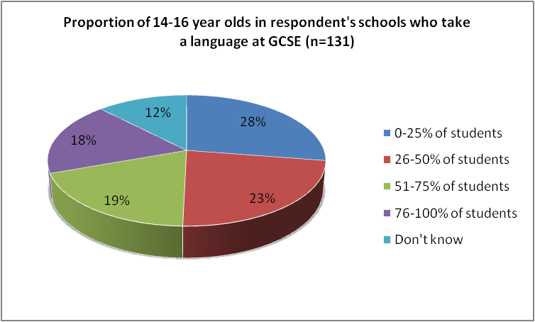

Education Maintenance Allowance (EMA)

- The sending out of the survey came at a time when the Coalition government had already announced the abolition of the EMA and there was uncertainty about what kind of student support would be put in its place.

- Sixty per cent of respondents (n=404) considered EMAs to be very important and a further 29 per cent quite important. Furthermore most respondents held strong views on the negative impact of removing the EMA and replacing it with targeted support. Over 80 per cent of those who responded (n=397) agreed that this would impact negatively on the number of students staying on in education post-16 and half of those who responded strongly agreed. This proved also to be the case when respondents were asked about the impact of the removal of EMAs on the retention of students (n=394).

- Whilst still in a minority, respondents in schools were slightly more likely to disagree that there would be a negative impact on participation in post-16 education, retention and attendance caused by the removal of the EMA than was the case in colleges (including sixth form colleges). For example, one quarter of school respondents disagreed that it would impact negatively on numbers staying on in post-16 education, compared to 13 per cent of sixth form college respondents and 16 per cent of FE/Tertiary college respondents.

- The majority of respondents (n=397) agreed that the removal of EMAs would impact negatively on student attainment, although a further third did not agree. Only 12 per cent thought it would have no impact at all on their institution and 22 per cent little impact. College respondents were found to be more likely than school respondents to strongly disagree that the removal of EMAs would have little or no impact on their institution.

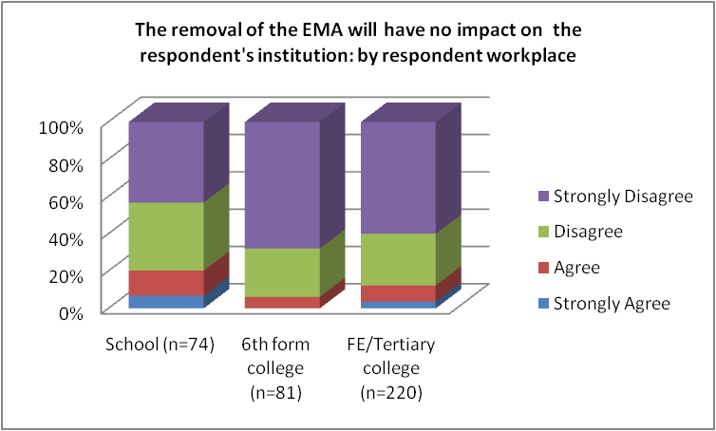

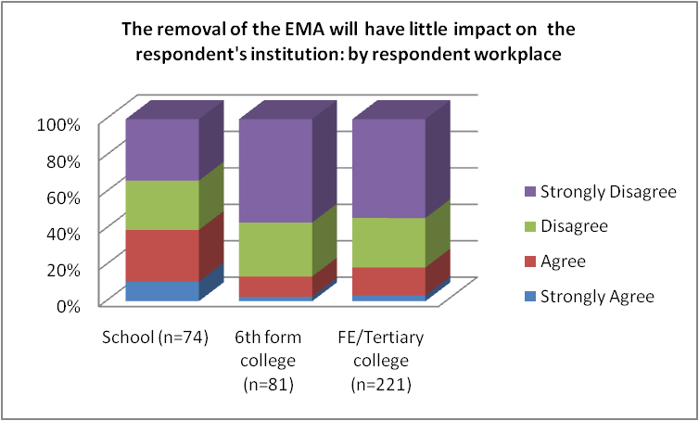

“Offering students an opportunity to explore their potential is vital. EMA was an enormous boon to that and will be sadly missed.” (Sixth form college)

“EMA should be given for achievement and not attendance.” (School)

“Cutting funding for supporting students and cutting financial support (EMA) does not sit with the widening participation agenda and raising the school leaving age.” (Sixth form college)

“I think the removal of the EMA will deter some students from coming. However I think the ones that do come will then be more self motivated to attend....we have a number of students who are only at college to collect EMA and they are a disaster: disruptive and don’t work much, we will be better off without them”. (Sixth form college)

Qualifications design and development

- The large majority of respondents agreed that teachers/lecturers, school/college leaders, awarding bodies and HE providers should all be involved in the design and development of general qualifications, such as GCSEs and A Levels, as well as vocational/applied qualifications.

- Those teaching in schools were more likely than those in colleges to strongly agree that school/college leaders should be involved in both types of qualifications. For general qualifications, 61 per cent of 110 school respondents strongly agreed compared to 40 per cent of sixth form respondents and 31 per cent of FE/Tertiary college respondents. In relation to vocational/applied, 53 per cent of the 108 school respondents strongly agreed compared to 38 per cent of the sixth form respondents and 32 per cent of the FE/Tertiary college respondents

- Whilst the majority also agreed that employers should be involved in the design and development of both types of qualifications, respondents were more likely to support their involvement in vocational/applied qualifications (93% of 412 respondents) than general qualifications (76% of 410 respondents).

“College leaders sometimes have no qualifications/experience in FE teaching or the subject specialism.” (College)

“Employers would use this as an opportunity to channel the teaching of knowledge and skills that they alone want. Leaving out essential learning/skills etc.” (College)

“Qualifications need to reflect what is needed by industry and not what an awarding body feels is appropriate.” (College)

“Seem to be designed by people who cannot remember what it is like to either teach or be a student. Further confirmed by exam board meetings.” (sixth form college)

What it feels like to be a teacher/lecturer in the current policy context

- In the final part of the questionnaire, teachers and lecturers were invited to make further comments. Below is a selection of these statements that illustrate some of the common opinions expressed. These include concerns about low morale, the current and future state of education/qualifications, the impact of sector cuts and, particularly for those in colleges, transitions from school to further education:

In the current climate of extremely high youth unemployment and the rise in tuition fees, it is increasingly difficult to motivate students as they are quite often despondent about their future and hence their further education. The morale of a whole generation is very low.” (Sixth form college)

“The rich elite will continue to avoid state education and the middle class will fight over the ‘best of the rest’. Poor kids from disadvantaged backgrounds don’t stand a chance.” (Sixth form college).

“Education cannot be run on a business model. Out system is an exam factory which gets in the way of learning. I think the quality of students is declining. Education should be about gaining skills and knowledge and not used as a political football.” (Sixth form college)

“I feel that FE is more focused on the retention and achievement of exams for finance and that the real focus of preparing the student for their next step in life has been lost” (College)

“Students arrive at the college where I work tend to need a lot of support at first to get to grips with the difference between GCSE material and further education material. Putting pressure on colleges to do in 2 years what formal education over 10 or more years has failed to do – e.g. ensure competency in literacy and numeracy – is unacceptable, especially when taking into account the relative resources available to schools and stand alone colleges.” (College)

“Education is no longer about love of learning. More a qualification game” (Sixth form college)

CONCLUSIONS AND NEXT STEPS

- This survey was undertaken during the first year of the newly elected Coalition Government and at a time of considerable change: policies associated with the previous Government were only barely bedding in, while new policies that directly challenged them were already entering the landscape. It is clear from the responses to this questionnaire that 14-19 education and training is a complex, turbulent and sometimes bewildering area of education to work in for teachers and lecturers and that there is often no settled will on key aspects of national policy.

- Given the benefit of hindsight it is possible to see that some of the contradictory findings in this survey reflect professional responses to a torrent of developments over the past 10 years, but with the absence of an overarching vision during the last five. The professional consensus (or even vision) that was gradually built up around the Tomlinson proposals for an inclusive and unified 14-19 system, with broader programmes of learning for students at all levels, has been shattered. These survey responses seem to suggest a move towards greater professional pragmatism as teachers and lecturers find themselves dealing with existing students, the tensions between different qualifications and the accountability system and the distant, but powerful influence of employers and universities. Greater professional sectionalism appears to be evident too, based on which institution the respondents work in and the day-to-day problems they experience in that setting.

- The tensions between the needs of learners and those of the institutions within which they are studying are also apparent in many of the responses to the survey. Although there are subtle difference between the responses of those working in schools and those working in colleges, there are some clear common messages across both sectors about the current qualifications and programmes on offer to 14-19 year olds. Overall the survey indicates greater confidence in the currency and progression value of the more traditional awards, but with a recognition that newer qualifications may well be motivational and provide a broad programme of learning for young people. This is an issue which curriculum managers and institutional leaders have to grapple with on an annual basis as they decide what to offer the 14-19 year olds in their institution. They have to decide whether to stick to the traditional awards such as GCSEs and A Levels and risk alienating or excluding large sections of the cohort or experiment with newer and possibly more motivational awards and risk serving learners badly in terms of qualifications recognition and progression. Unfortunately, it is not obvious that the Schools’ White Paper or the recommendations from the Wolf Review fully address, let alone resolve this problem.

- Underlying the more detailed responses to this survey lie a number of bigger problems about the hostile external environment that forms the backdrop to teachers’ professional lives and the lives of their learners. The most clearly articulated issue is the need to motivate learners to participate in education and training up to the age of 18 at a time of high youth unemployment, shrinking education budgets, steep rises in higher education fees and the removal of the EMA.

- Given this new context, it is vital for teacher and lecturer unions to be in the forefront of re-opening the debate about the aims and purposes of 14-19 education and training that was effectively closed down after the Tomlinson Review in 2004. Following a decade of qualifications reform that began with Curriculum 2000 and has intensified over the last five years, it is time to use the experience gained from this experimentation to cast light on the bigger questions about 14-19 education and training that still remain unanswered despite continual change.

- Is there a core of knowledge and skills that all young people should master between the ages of 14-19?

- What shape should the curriculum take to ensure both engagement and progression for young people?

- What form or forms of accreditation best serve the needs of all 14-19 year olds?

- Where should young peoples study and how do we ensure high quality learning in different contexts?

- What kind of initial teacher training and continuing professional development is needed for the 14-19 phase?

- How can the voices of practitioners, who are best placed to know the needs of their learners, be more actively used in the policy process?

- Perhaps it is more important still for both the NUT and UCU to accept that a professional consensus about the future direction of 14-19 education is no longer there to be harnessed. It has to be rebuilt. In debating the findings from this survey and the broader questions they raise, is it now time for the NUT and UCU to begin the reconstruction of a more visionary, consensual and coherent approach to change?

ACKNOWLEDGEMENT

Thank you to Robert Cheesman (NUT) and Caroline Wickenden (IoE) for all their work on this survey.

