Equality Bill: Submission to Public Bill Committee June 2009
1. Introduction
The University and College Union represents 118,000 lecturers and academic related staff in higher and further education. Our members are employed in a wide range of institutions from “old universities” to prisons and adult education colleges.
UCU welcomes the Equality Bill. We have long campaigned for the harmonisation and simplification of equality legislation. We are concerned to ensure that the Bill achieves the Government’s stated intention of levelling up with no dilution of existing equality rights.
This submission highlights a number of areas where we believe more attention needs to be given to the implementation of certain provisions within the Bill.
2. Disability discrimination
UCU recognises the efforts that have been made within the Bill to reproduce existing rights for disabled people, and in some areas to extend them for example by the introduction of discrimination arising from disability and the application of indirect discrimination to disability. We also welcome the extension of discrimination by association to all protected characteristics.
UCU is concerned that the “one size fits all” approach of the Equality Bill will not adequately address the importance of more favourable treatment for disabled people contained within the Disability Discrimination Act. This is an essential component if we are to achieve equality for disabled people.
UCU is further concerned that the definition of disability within the Disability Discrimination Act has been largely retained. We would support the abolition of the definition and for an approach to be taken based on the social model of disability.
Clause 13 – direct discrimination
The Bill replaces the current established use in equality and anti discrimination legislation of “on the grounds of” with “because of”. UCU is concerned about the potential confusion and dilution of existing rights which may arise from this change. The new formulation may be interpreted as requiring a demonstration of intent or motivation to discriminate which is not currently required.
UCU would support retaining the current use “on the grounds of” which is a well understood part of UK and European anti-discrimination law.
Clause 14 – discrimination arising from disability
UCU warmly welcomes the stated intention of this clause to re-establish protection for disabled people following the Lewisham v Malcolm case. We are concerned however that the formulation “because of B’s disability” rather than “related to B’s disability” will mean the protection is narrower than intended and narrower than the protection available before the House of Lords decision in the Malcolm case.
As stated above in relation to clause 13 and direct discrimination, UCU’s concern is principally that “related to” does not imply intention or motivation while “because of” may do so. This will limit the scope of this provision.
Clauses 19-22 – duty to make reasonable adjustment
UCU welcomes the introduction of a single trigger of “substantial disadvantage” to make reasonable adjustments. However, we are concerned that clause 19 requires the comparator for assessing substantial disadvantage to be with a non disabled person. We believe this will narrow the application of the duty to make reasonable adjustments.
- Equal pay
It is widely recognised that the Equal Pay Act has failed to achieve equality in pay between men and women. UCU believes the Equality Bill should contain three measures to ensure real action to end pay discrimination: the introduction of mandatory pay audits, the introduction of representative action and the use of hypothetical comparators in equal pay cases.
Gender pay gap reporting: clause 73
UCU acknowledges the introduction in the Bill of the provision for gender pay reporting. We believe the current provisions are too weak: they currently only cover private sector employers with over 250 employees; they would not be introduced until after 2013 and they require very limited information to be published.
UCU believes this clause of the Bill should be strengthened to require all employers to carry out regular comprehensive equal pay audits. The pay gap between male and female employees remains shamefully wide. In Higher Education the gender pay gap between the mean average earnings of teaching professionals is 18.2%. In Further Education it is 8.6%. (Annual Survey of Hours and Earnings 2008). As the detailed data in the appendix shows, the gap in further education has not narrowed in the past decade and in higher education it has widened.
In the further education and higher education sectors UCU, along with the other recognised unions, has national agreements based on EOC guidance calling on employers to undertake regular equal pay reviews. Very few employers have complied and the pay gaps in each sector remain too wide. Numerous national pay agreements have required employers to take steps to address the disparity in pay between male and female employees. The voluntary approach is not working. We strongly believe the Equality Bill should introduce mandatory pay audits for all employers which would require:
- Identification of any disparity of pay between men and women
- Analysis of the reasons for any identified differences
- Action plans to rectify the anomalies
Furthermore, UCU believes that where an employer fails to publish the required pay audit, they should not be entitled to submit a material factor defence in relation to any period for which they are in breach of their obligations.
Hypothetical comparators
UCU believes that the Bill should allow the use of hypothetical comparators in equal pay cases where no actual comparator exists. This would bring the UK in line with the EU Equal Treatment Directive. This measure would be particularly helpful for women in female dominated occupations or in small workplaces. The absence of a male colleague currently bars women from taking a case, despite the fact that occupational segregation is one of the key contributors to the pay gap.
Representative action
The Equality bill should allow trade unions or the Equality and Human Rights Commission to bring a claim on behalf of a group of women in equal pay cases. This would reduce the burden on all involved with the tribunal process and would not place such an undue emotional and financial burden on individual claimants.
4. Clause 118 – enforcement by employment tribunals
UCU welcomes the introduction of powers for tribunals to make recommendations requiring employers to take action as a result of the findings in individual cases.
5. Public sector duty regarding socio-economic inequality
UCU welcomes the introduction of the new public sector duty regarding socio-economic inequality but notes the limited number of public authorities which will be covered by this duty. We would support an extension of this duty to cover a wider range of public authorities. We also note that without enforcement powers this new duty is unlikely to be effective.
6. Public sector equality duty – clause 143
UCU notes the clause makes it clear that complying with the duty may mean treating some people move favourably than others. This will of course include treating disabled people more favourably than non –disabled people. However, we are concerned that as drafted the Equality Bill does not have the power of the requirement under the Disability Equality Duty in this regard.
Specific duties – clause 147
UCU will respond to the consultation exercise to be undertaken shortly by the EHRC on the regulations to impose specific duties. We would highlight the following areas where we believe the specific duties must mirror the current requirements under the race, gender and disability duties:
- The requirement to consult trade unions (as currently contained within the gender equality duty)
- The requirement to involve disabled people. This should be extended within the new specific duties to cover all protected characteristics and the involvement of all relevant groups and stakeholders.
- The requirement to equality impact assess new or existing policies and/or practices.
Enforcement – clause 150
UCU believes the Equality Bill should contain powers for individuals or trade unions at private law in relation to the enforcement of the public sector duty. The provisions within clause 150 mirror the current situation: enforcement is via the EHRC or judicial review. This is unsatisfactory. It is unrealistic to expect the EHRC to enforce the duty across each public authority. Their role is best placed investigating specific sectors of the labour market or investigating those authorities of strategic importance. If the extended public sector duty is to be effective and bring about meaningful change, there cannot continue to be a situation where the majority of public sector employers can act with impunity.
- Pregnancy discrimination: clause 16(7)
UCU believes clause 16(7) should be deleted as it substantially dilutes current protection for pregnant women by introducing a test of reasonableness. We are extremely concerned about the implications of this change in formulation as it may allow employers to defend discrimination on the grounds of convenience or cost. It is particularly important that this is deleted at a time when increased discrimination against pregnant workers is being reported.
- Additional measures
There are a number of areas detailed below which we believe should be included in the Bill.
Equality representatives
UCU is disappointed that the Equality Bill does not contain provision for the right to paid time off for trade union equality reps. We note the Government’s stated intention to strengthen the role of equality reps but believe the most effect method would be to provide a statutory footing for these representatives.
Multiple discrimination
UCU strongly supports the introduction of measures to the Bill to allow claimants to bring direct discrimination, indirect discrimination, harassment or victimisation claims on the grounds of multiple discrimination. We have responded to the recent consultation exercise.
APPENDIX
Pay gaps

Gender pay gaps (ASHE)

The figures in the table, from the government’s Annual Survey of Hours and Earnings (ASHE), indicate the extent to which mean average earnings for females lags behind that of males. Data for higher education teaching professionals excludes research-only academics. ASHE data are based on a sample taken in April.
Gender pay gaps, UK
Year at April | All employees | Public sector | Higher education teaching professionals | Further education teaching professionals
1998 | 28.1% | 20.3% | 17.0% | 8.7%
1999 | 27.0% | 19.8% | 17.7% | 9.8%
2000 | 26.9% | 18.5% | 14.2% | 8.6%
2001 | 26.4% | 18.6% | 18.2% | 11.4%
2002 | 26.1% | 17.9% | 17.8% | 14.6%
2003 | 25.7% | 18.2% | 17.2% | 12.4%
2004 | 24.3% | 17.5% | 14.3% | 8.9%
2005 | 23.5% | 19.0% | 17.5% | 12.8%
2006 | 23.3% | 19.3% | 16.4% | 11.2%
2007 | 23.6% | 19.2% | 17.2% | 11.1%
2008 | 23.1% | 18.7% | 18.2% | 8.6%

Full-time employees on adult rates whose pay for the survey pay-period was not affected by absence. Data based on the mean average. Source: Annual Survey of Hours and Earnings (ASHE), table 14.1a ‘Weekly pay - Gross (£) - For full-time employee jobs: United Kingdom’; percentage calculations by UCU.

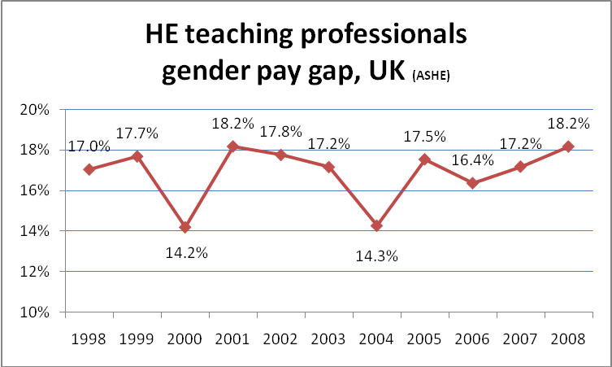
Full-time employees on adult rates whose pay for the survey pay-period was not affected by absence. Data based on the mean average. Source: Annual Survey of Hours and Earnings (ASHE), table 14.1a ‘Weekly pay - Gross (£) - For full-time employee jobs: United Kingdom’; percentage calculations by UCU.

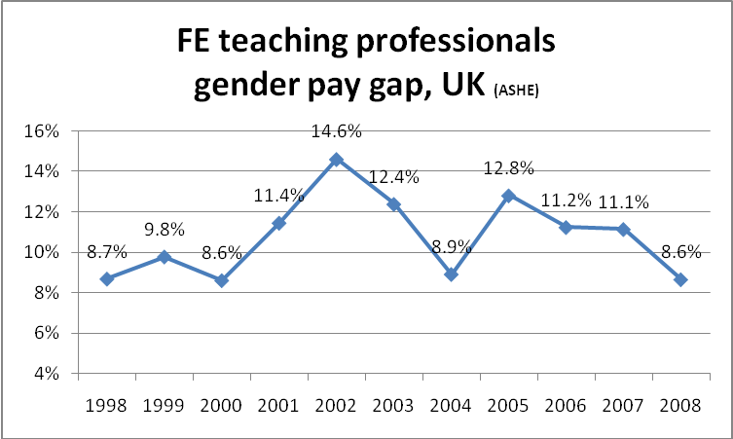

Full-time employees on adult rates whose pay for the survey pay-period was not affected by absence. Data based on the mean average. Source: Annual Survey of Hours and Earnings (ASHE), table 14.1a ‘Weekly pay - Gross (£) - For full-time employee jobs: United Kingdom’; percentage calculations by UCU.

Gender pay gap in Higher Education (HESA)

The figures in the table, from the Higher Education Statistics Agency (HESA), indicate the extent to which the mean average salary for female academics lags behind that of males. The data include teaching-only, research-only and teaching-and-research academics; the data also include clinical academics, but excludes London weighting from 2003-4. While ASHE data are based on a sample, HESA data is based on a census of staff employed at the end of July in the relevant academic year (August to July).

August-July academic year | GP gap
1995-6 | 14.5%
1996-7 | 14.8%
1997-8 | 14.6%
1998-9 | 15.4%
1999-2000 | 15.6%
2000-1 | 15.4%
2001-2 | 15.2%
2002-3 | 14.9%
2003-4 | 14.1%
2004-5 | 14.4%
2005-6 | 14.1%
2006-7 | 13.73%
2007-8 | 13.67%

Full-time UK employees mean average salary. Source: Higher Education Statistics Agency (HESA); percentage calculations by UCU.
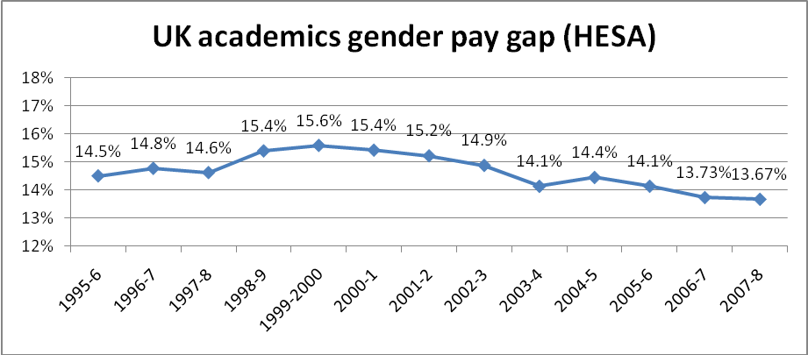

Full-time UK employees mean average salary. Source: Higher Education Statistics Agency (HESA); percentage calculations by UCU.
Ethnicity pay gap (HESA)

UK academic staff

The table shows the average salaries of white and non-white UK academic staff, and the extent to which average salaries for non-white academic staff lag behind those of their white colleagues.

 | White (W) |  | Non-white (NW) | NW as % W | Ethnicity  pay gap
2004-5 |  | £37,313 | £32,587 | 87.3% | 12.7%
2005-6 |  | £39,719 | £34,963 | 88.0% | 12.0%
2006-7
2007-8 |  | £44,382 | £38,773 | 87.4% | 12.6%

Full-time UK employees mean average salary. Source: Higher Education Statistics Agency (HESA); percentage calculations by UCU. Includes teaching-only, research-only, teaching-and-research, and clinical academics.

