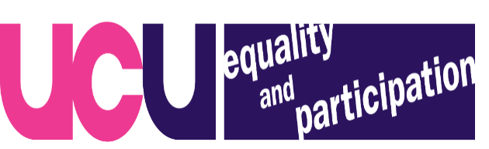

March 2019

The new far right:
who are Generation Identity?

This report has been written by activists from the
University and College Union for Stand Up to Racism

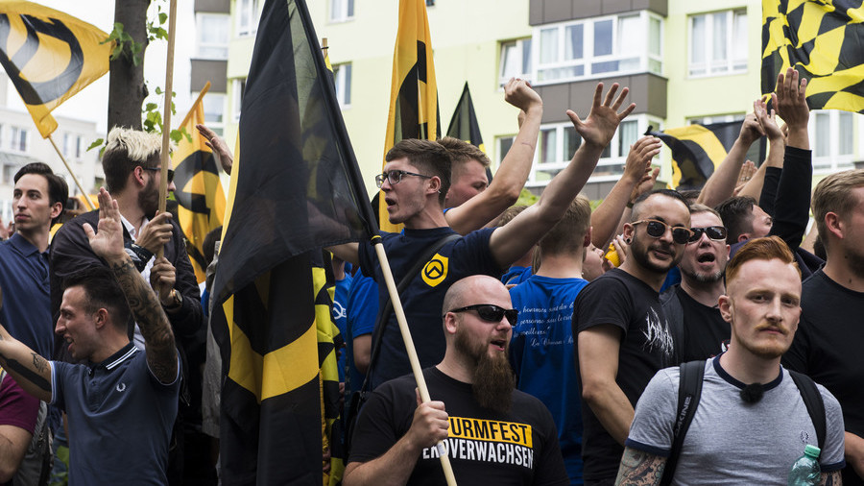GI members have links to far right and fascist groups across Europe.

Who are Generation Identity?
Generation Identity (GI) are a small, but well-organised group of far-right activists in the UK and Ireland who are part of a network with branches across Europe. They emerged from the French Nouvelle Droite (New Right) in the early 2000s and are led by Martin Sellner, an Austrian activist. Sellner's group shot to prominence for organising attacks on refugees, including rushing the stage during a play performed by refugee actors at the University of Vienna in 2016 and throwing fake blood over the performers. They also raised over £150,000 to charter a ship in order to sink boats bringing refugees into Europe across the Mediterranean. They are well-connected with the US alt-right: Martin Sellner's fiancée, Brittany Pettibone is US alt-right vlogger and conspiracy theorist.
Although GI in the UK and Ireland have a tiny number of supporters – their first 'national' demonstration in 2018 attracted only 40 people – they have become increasingly active on university campuses. At least 24 universities around the UK have seen some form of GI activity, ranging from stickering to elaborate 'stunts' such as pouring red dye in a fountain in Bristol and blaring out racist Tory MP Enoch Powell's 1968 'Rivers of blood' speech.
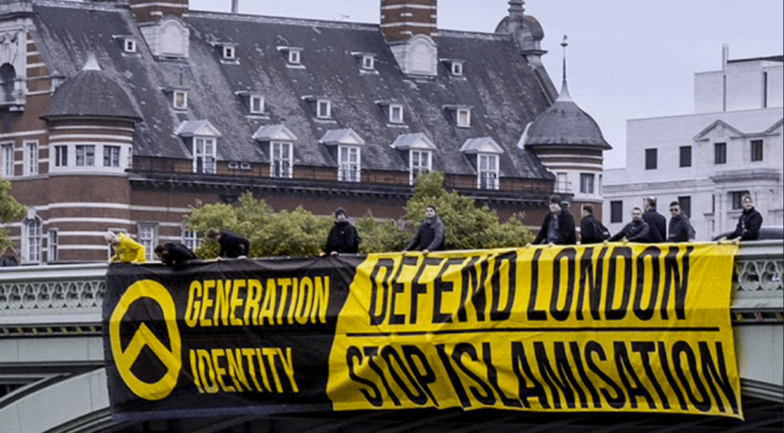Islamophobic GI stunt in London in 2018

What do they stand for?
GI claim to be 'non-violent' and their slick media-friendly campaigns are designed to differentiate them from the traditional image of Nazi street thugs. In reality, they want to create mass support for ideas which can only be implemented through huge increases in state racism and violence against migrants and refugees. According to GI's 'theorists' the 'European ethno-cultural identity' is under threat from migration and the emergence of a multicultural society. This is a code-word for white supremacy. GI activists spout Islamophobic conspiracy theories about a 'Great Replacement' of white, Christian Europeans by Muslims. They want to see the living conditions and democratic rights for Europe's non-white communities degraded to the extent that people will "voluntarily" leave. For those that refuse, there is then the final option of forced "repatriation". Unsurprisingly, GI have been building links with UK fascist groups and individuals, including Tommy Robinson, and were exposed in 2018 as having recruited a member of the banned Nazi terror group National Action.
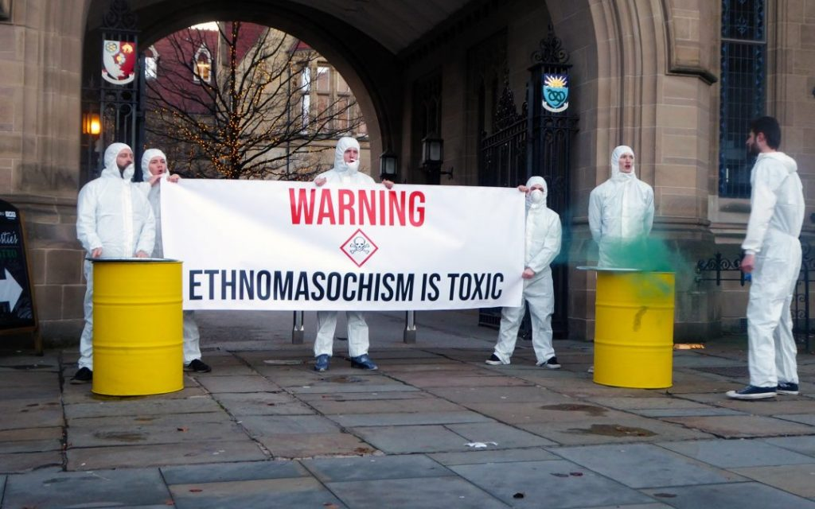
GI stunt in Manchester in 2018.

What do they do?
GI activities have ranged from 'stunts' such as banner drops and stickering to holding 'study group' sessions as well as social media campaigns. Their activists target student union and trade union leaders for abuse. In December 2018 GI activists stood in hazmat suits outside the University of Manchester next to barrels of "toxic waste" haranguing passers-by about "ethnomasochism" after SU Diversity Officer Riddi Visu spoke out against the group's Islamophobic posters on campus. Riddi Visu was also abused by GI supporters on Facebook. In March 2018, UCU Vice-President Nita Sanghera, who has spoken at dozens of university campuses as part of a speaking tour organised by Stand up to Racism was abused on Twitter by GI supporters.
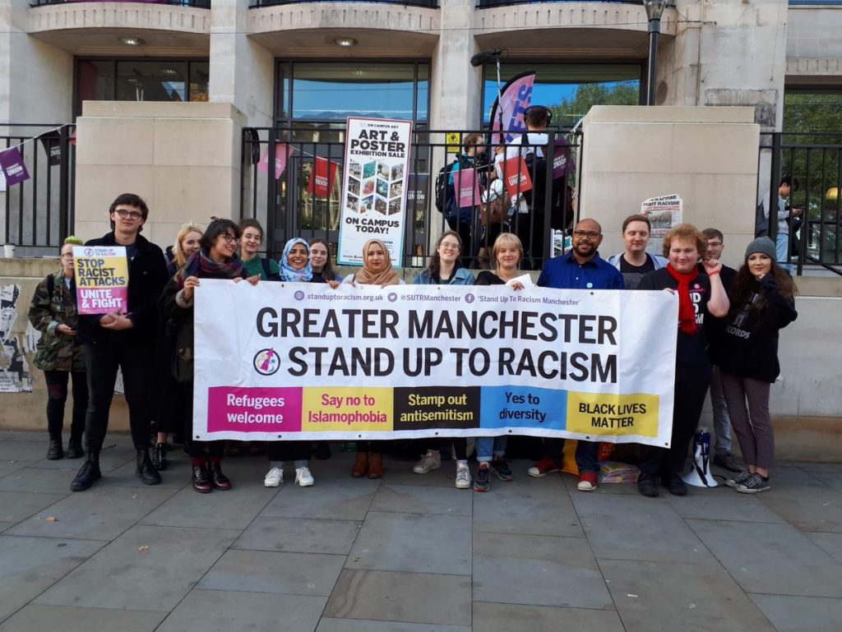The response to GI from Stand Up to Racism in Manchester.

What can we do?
Our campuses and colleges should be free from any racism, staff and students should be able to learn and live without fear from verbal or physical abuse of any kind. The volume of racist harassment and incidents on UK campuses prompted the Equality and Human Rights Commission (EHRC) to launch an inquiry late last year. The rise of institutional racism in society has given confidence to racists and far right to target campuses and colleges in order to recruit young people to their violent and poisonous ideas.
GI are not the only far-right group active on campuses. Abusive 'stunts' have taken place at "White T Shirt socials", where students wrote messages to each other making Islamophobic comments, misogynistic and anti-Semitic references denying the Holocaust.
Uniting a broad group of people against the far right whether they be Tommy Robinson and the DFLA, or Generation Identity or Holocaust deniers, or Islamophobic racists can seem overwhelming. Small initiatives, such as petitions to all staff and students, taking a selfie with a group message such as, "No Nazis on our campus", using social media, or doing a campus solidarity walk about taking down posters or stickers in a group, are a good place to start. When far right activists formed a campus-based 'Traditionalist Society' at Lancaster University, the UCU Branch was able to organise brilliant campaign by uniting staff and students, using petitions and meetings on campus. Similar and successful campaigns have taken place at Exeter, Newcastle, Dundee, Bristol and many others.
We have to drive back these openly racist and far right ideas by organising collectively in Universities and Colleges to bring together the largest numbers of staff and students against these poisonous ideas that seek to divide.
University College Union and Stand up to Racism organised a campus tour late last year, which saw hundreds attend workshops, meetings and debates with faith groups, MPS, community organisations as to how we can best unite our forces against those who seek to divide us. We have to continue this work and allow no place for these violent and dangerous ideas to spread.
Please follow the link for more information:
http://www.standuptoracism.org.uk/the-new-far-right-who-are-generation-identity/

